- 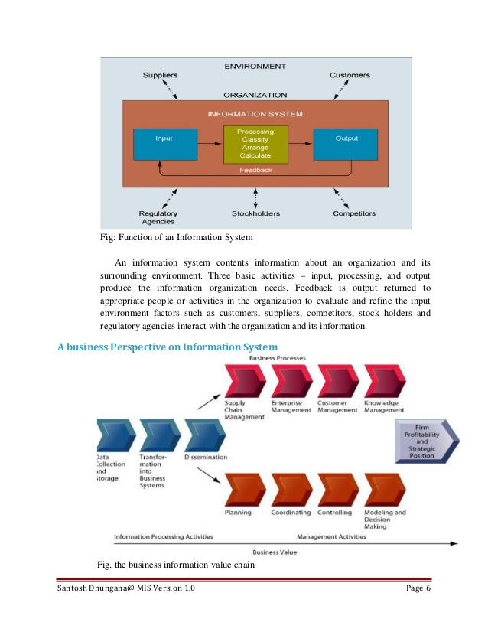Upload
- Login
- Signup

Top of Form
Bottom of Form
- Home

- Technology

- Education

- More Topics
- For Uploaders
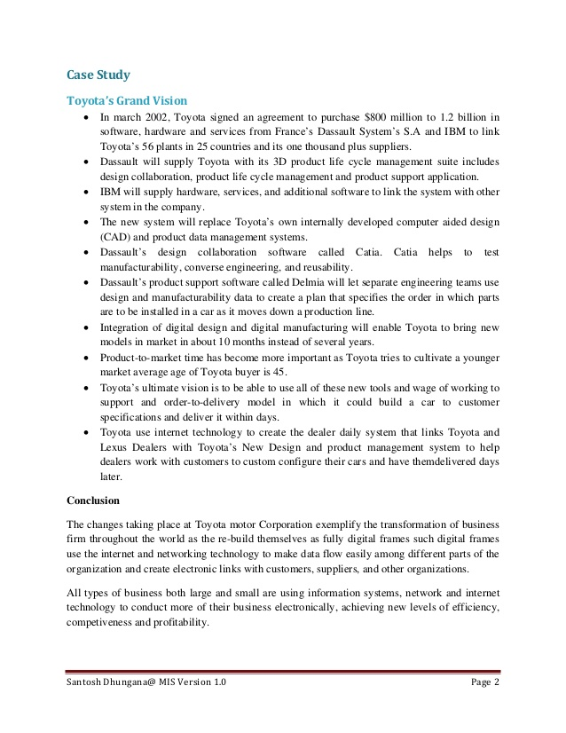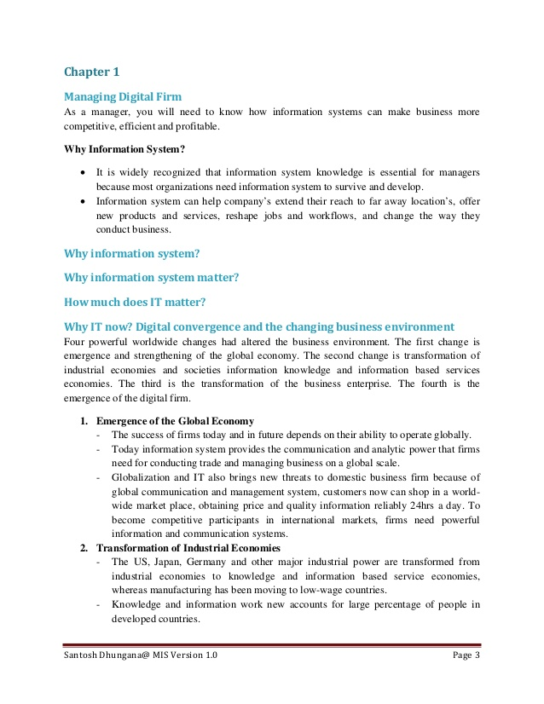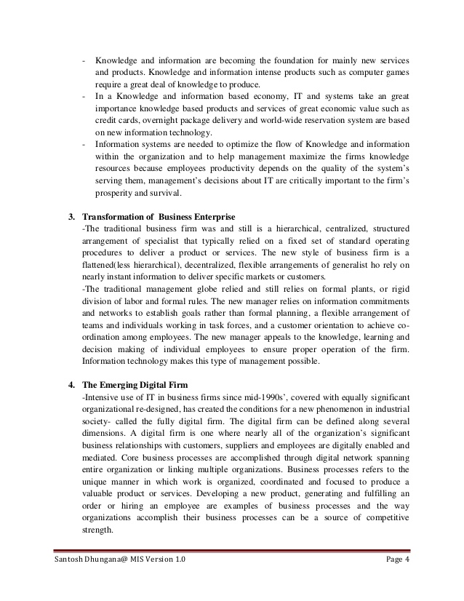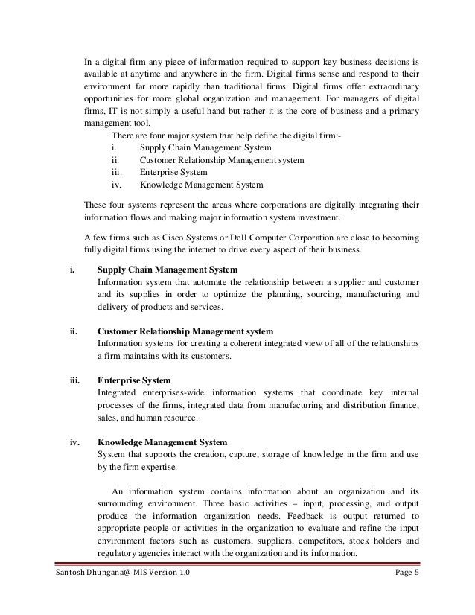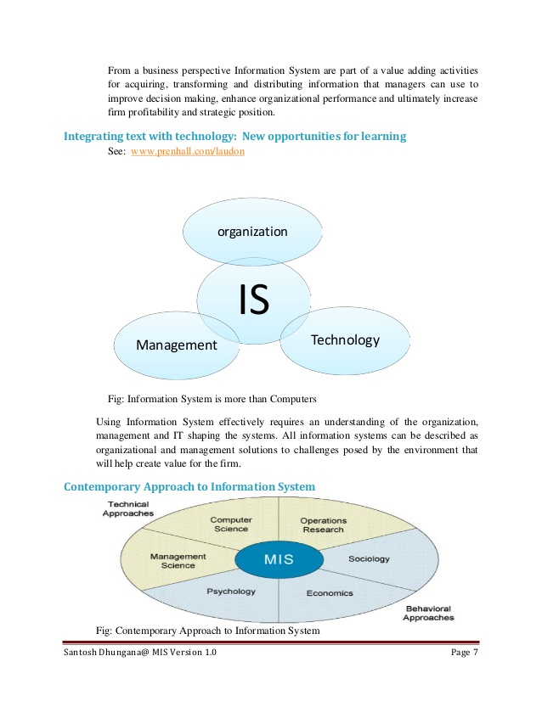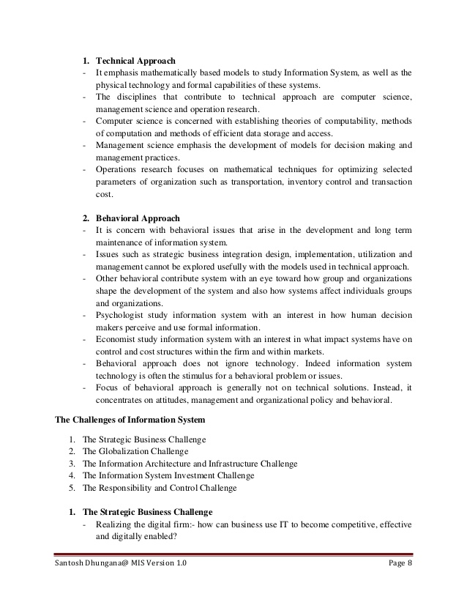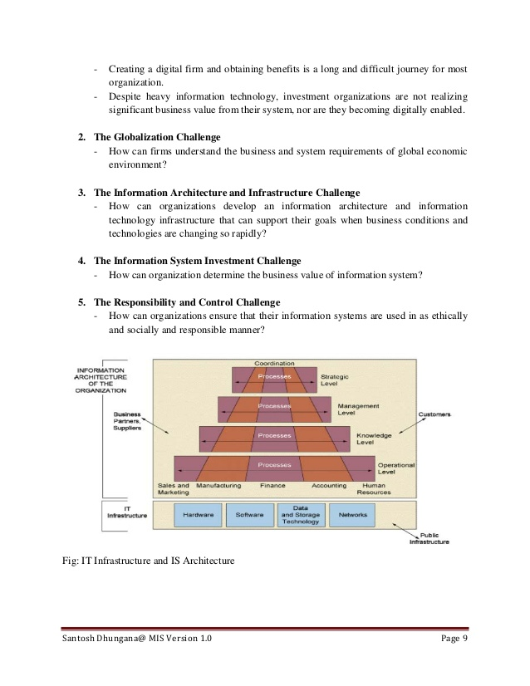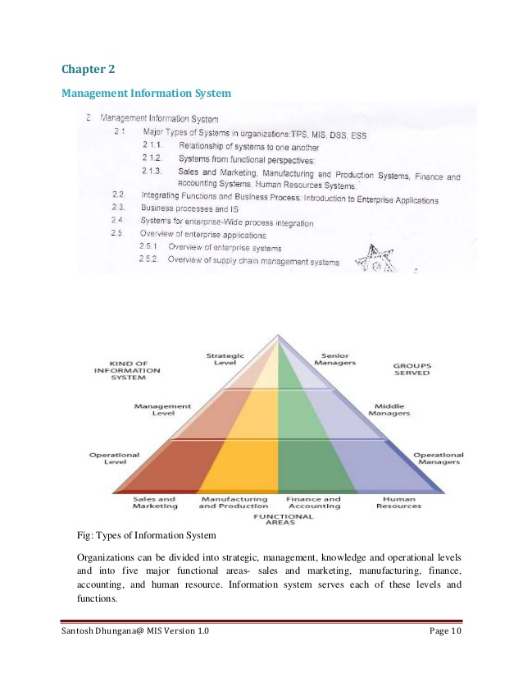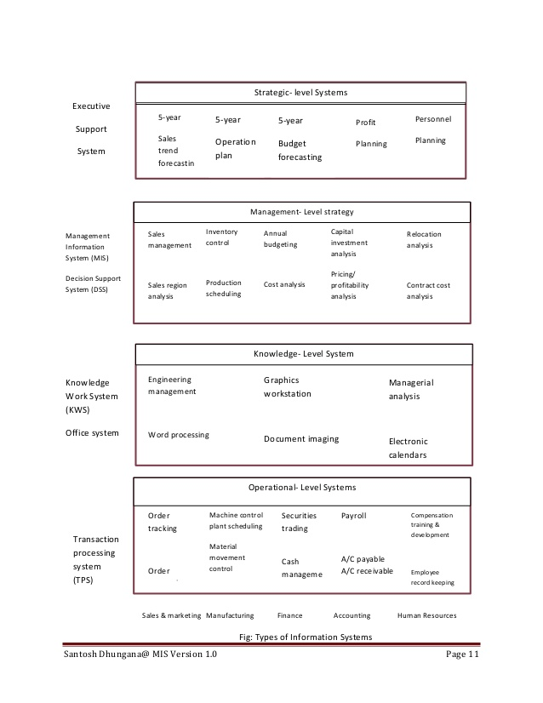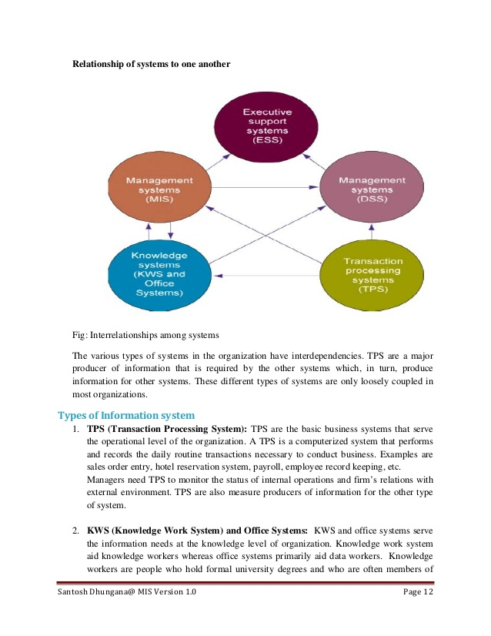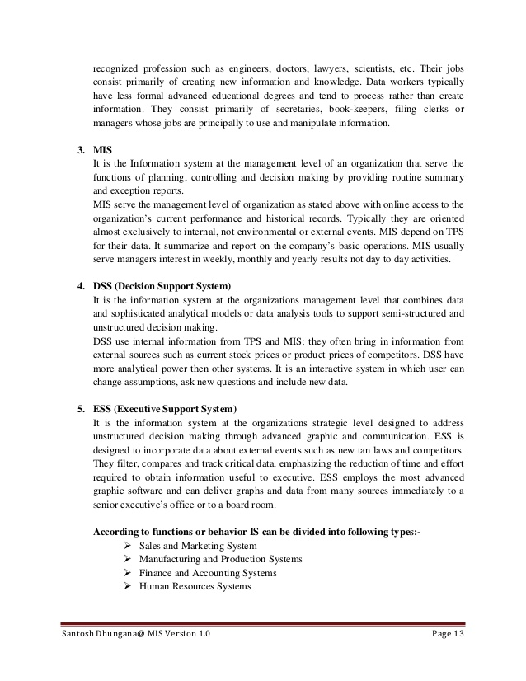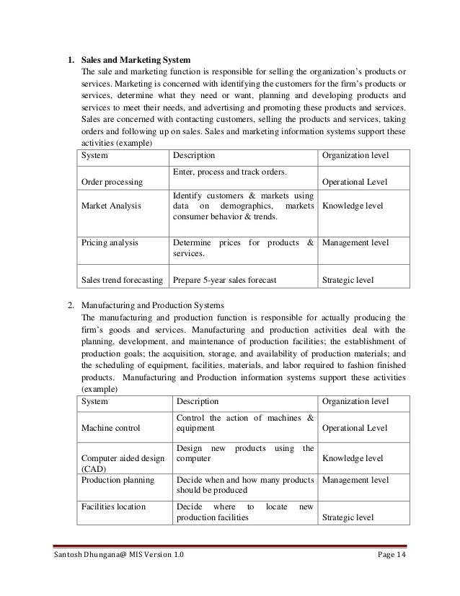
9 of 60

Management Information System (Full Notes)
Bottom of Form
- Be the first to comment

Management Information System (Full Notes)
- 1. Lecture Handout on Management Information System (MIS) for the program BIM Seventh Semester, Tribhuvan University. Specially for my students of Prime College, Nayabazar, NCCS, Pakanajol, Asian School of Management and Technology, Gongabu and CAB, Naxal Dear students this note is just class handouts. I am very thankful to my student Mr. Dibas Gaudel (Asian College) for his effort in typing this note so perfectly. It doesn’t cover all the topics of the syllabus so please take this as a guide. For any confusion please go through the soft copy of your text book and also follow the chapter wise notes that I have given in the class room. I will provide you the newer version of the note once I change this initial version before your board exam. For any questions: Feel free to contact me: Er. Santosh Dhungana Lecturer: Prime College, NCCS, CAB and Asian Santosh.dhungana@gmail.com Skype: sansarangel Copyright:: Santosh Dhungana Santosh Dhungana@ MIS Version 1.0 Page 1
- 2. Case Study Toyota’s Grand Vision • In march 2002, Toyota signed an agreement to purchase $800 million to 1.2 billion in software, hardware and services from France’s Dassault System’s S.A and IBM to link Toyota’s 56 plants in 25 countries and its one thousand plus suppliers. • Dassault will supply Toyota with its 3D product life cycle management suite includes design collaboration, product life cycle management and product support application. • IBM will supply hardware, services, and additional software to link the system with other system in the company. • The new system will replace Toyota’s own internally developed computer aided design (CAD) and product data management systems. • Dassault’s design collaboration software called Catia. Catia helps to test manufacturability, converse engineering, and reusability. • Dassault’s product support software called Delmia will let separate engineering teams use design and manufacturability data to create a plan that specifies the order in which parts are to be installed in a car as it moves down a production line. • Integration of digital design and digital manufacturing will enable Toyota to bring new models in market in about 10 months instead of several years. • Product-to-market time has become more important as Toyota tries to cultivate a younger market average age of Toyota buyer is 45. • Toyota’s ultimate vision is to be able to use all of these new tools and wage of working to support and order-to-delivery model in which it could build a car to customer specifications and deliver it within days. • Toyota use internet technology to create the dealer daily system that links Toyota and Lexus Dealers with Toyota’s New Design and product management system to help dealers work with customers to custom configure their cars and have themdelivered days later. Conclusion The changes taking place at Toyota motor Corporation exemplify the transformation of business firm throughout the world as the re-build themselves as fully digital frames such digital frames use the internet and networking technology to make data flow easily among different parts of the organization and create electronic links with customers, suppliers, and other organizations. All types of business both large and small are using information systems, network and internet technology to conduct more of their business electronically, achieving new levels of efficiency, competiveness and profitability. Santosh Dhungana@ MIS Version 1.0 Page 2
- 3. Chapter 1 Managing Digital Firm As a manager, you will need to know how information systems can make business more competitive, efficient and profitable. Why Information System? • It is widely recognized that information system knowledge is essential for managers because most organizations need information system to survive and develop. • Information system can help company’s extend their reach to far away location’s, offer new products and services, reshape jobs and workflows, and change the way they conduct business. Why information system? Why information system matter? How much does IT matter? Why IT now? Digital convergence and the changing business environment Four powerful worldwide changes had altered the business environment. The first change is emergence and strengthening of the global economy. The second change is transformation of industrial economies and societies information knowledge and information based services economies. The third is the transformation of the business enterprise. The fourth is the emergence of the digital firm. 1. Emergence of the Global Economy - The success of firms today and in future depends on their ability to operate globally. - Today information system provides the communication and analytic power that firms need for conducting trade and managing business on a global scale. - Globalization and IT also brings new threats to domestic business firm because of global communication and management system, customers now can shop in a world- wide market place, obtaining price and quality information reliably 24hrs a day. To become competitive participants in international markets, firms need powerful information and communication systems. 2. Transformation of Industrial Economies - The US, Japan, Germany and other major industrial power are transformed from industrial economies to knowledge and information based service economies, whereas manufacturing has been moving to low-wage countries. - Knowledge and information work new accounts for large percentage of people in developed countries. Santosh Dhungana@ MIS Version 1.0 Page 3
- 4. - Knowledge and information are becoming the foundation for mainly new services and products. Knowledge and information intense products such as computer games require a great deal of knowledge to produce. - In a Knowledge and information based economy, IT and systems take an great importance knowledge based products and services of great economic value such as credit cards, overnight package delivery and world-wide reservation system are based on new information technology. - Information systems are needed to optimize the flow of Knowledge and information within the organization and to help management maximize the firms knowledge resources because employees productivity depends on the quality of the system’s serving them, management’s decisions about IT are critically important to the firm’s prosperity and survival. 3. Transformation of Business Enterprise -The traditional business firm was and still is a hierarchical, centralized, structured arrangement of specialist that typically relied on a fixed set of standard operating procedures to deliver a product or services. The new style of business firm is a flattened(less hierarchical), decentralized, flexible arrangements of generalist ho rely on nearly instant information to deliver specific markets or customers. -The traditional management globe relied and still relies on formal plants, or rigid division of labor and formal rules. The new manager relies on information commitments and networks to establish goals rather than formal planning, a flexible arrangement of teams and individuals working in task forces, and a customer orientation to achieve co- ordination among employees. The new manager appeals to the knowledge, learning and decision making of individual employees to ensure proper operation of the firm. Information technology makes this type of management possible. 4. The Emerging Digital Firm -Intensive use of IT in business firms since mid-1990s’, covered with equally significant organizational re-designed, has created the conditions for a new phenomenon in industrial society- called the fully digital firm. The digital firm can be defined along several dimensions. A digital firm is one where nearly all of the organization’s significant business relationships with customers, suppliers and employees are digitally enabled and mediated. Core business processes are accomplished through digital network spanning entire organization or linking multiple organizations. Business processes refers to the unique manner in which work is organized, coordinated and focused to produce a valuable product or services. Developing a new product, generating and fulfilling an order or hiring an employee are examples of business processes and the way organizations accomplish their business processes can be a source of competitive strength. Santosh Dhungana@ MIS Version 1.0 Page 4
- 5. In a digital firm any piece of information required to support key business decisions is available at anytime and anywhere in the firm. Digital firms sense and respond to their environment far more rapidly than traditional firms. Digital firms offer extraordinary opportunities for more global organization and management. For managers of digital firms, IT is not simply a useful hand but rather it is the core of business and a primary management tool. There are four major system that help define the digital firm:- i. Supply Chain Management System ii. Customer Relationship Management system iii. Enterprise System iv. Knowledge Management System These four systems represent the areas where corporations are digitally integrating their information flows and making major information system investment. A few firms such as Cisco Systems or Dell Computer Corporation are close to becoming fully digital firms using the internet to drive every aspect of their business. i. Supply Chain Management System Information system that automate the relationship between a supplier and customer and its supplies in order to optimize the planning, sourcing, manufacturing and delivery of products and services. ii. Customer Relationship Management system Information systems for creating a coherent integrated view of all of the relationships a firm maintains with its customers. iii. Enterprise System Integrated enterprises-wide information systems that coordinate key internal processes of the firms, integrated data from manufacturing and distribution finance, sales, and human resource. iv. Knowledge Management System System that supports the creation, capture, storage of knowledge in the firm and use by the firm expertise. An information system contains information about an organization and its surrounding environment. Three basic activities – input, processing, and output produce the information organization needs. Feedback is output returned to appropriate people or activities in the organization to evaluate and refine the input environment factors such as customers, suppliers, competitors, stock holders and regulatory agencies interact with the organization and its information. Santosh Dhungana@ MIS Version 1.0 Page 5
- 6. Fig: Function of an Information System An information system contents information about an organization and its surrounding environment. Three basic activities – input, processing, and output produce the information organization needs. Feedback is output returned to appropriate people or activities in the organization to evaluate and refine the input environment factors such as customers, suppliers, competitors, stock holders and regulatory agencies interact with the organization and its information. A business Perspective on Information System Fig. the business information value chain Santosh Dhungana@ MIS Version 1.0 Page 6
- 7. From a business perspective Information System are part of a value adding activities for acquiring, transforming and distributing information that managers can use to improve decision making, enhance organizational performance and ultimately increase firm profitability and strategic position. Integrating text with technology: New opportunities for learning See: www.prenhall.com/laudon Fig: Information System is more than Computers Using Information System effectively requires an understanding of the organization, management and IT shaping the systems. All information systems can be described as organizational and management solutions to challenges posed by the environment that will help create value for the firm. Contemporary Approach to Information System Fig: Contemporary Approach to Information System IS organization TechnologyManagement Santosh Dhungana@ MIS Version 1.0 Page 7
- 8. 1. Technical Approach - It emphasis mathematically based models to study Information System, as well as the physical technology and formal capabilities of these systems. - The disciplines that contribute to technical approach are computer science, management science and operation research. - Computer science is concerned with establishing theories of computability, methods of computation and methods of efficient data storage and access. - Management science emphasis the development of models for decision making and management practices. - Operations research focuses on mathematical techniques for optimizing selected parameters of organization such as transportation, inventory control and transaction cost. 2. Behavioral Approach - It is concern with behavioral issues that arise in the development and long term maintenance of information system. - Issues such as strategic business integration design, implementation, utilization and management cannot be explored usefully with the models used in technical approach. - Other behavioral contribute system with an eye toward how group and organizations shape the development of the system and also how systems affect individuals groups and organizations. - Psychologist study information system with an interest in how human decision makers perceive and use formal information. - Economist study information system with an interest in what impact systems have on control and cost structures within the firm and within markets. - Behavioral approach does not ignore technology. Indeed information system technology is often the stimulus for a behavioral problem or issues. - Focus of behavioral approach is generally not on technical solutions. Instead, it concentrates on attitudes, management and organizational policy and behavioral. The Challenges of Information System 1. The Strategic Business Challenge 2. The Globalization Challenge 3. The Information Architecture and Infrastructure Challenge 4. The Information System Investment Challenge 5. The Responsibility and Control Challenge 1. The Strategic Business Challenge - Realizing the digital firm:- how can business use IT to become competitive, effective and digitally enabled? Santosh Dhungana@ MIS Version 1.0 Page 8
- 9. - Creating a digital firm and obtaining benefits is a long and difficult journey for most organization. - Despite heavy information technology, investment organizations are not realizing significant business value from their system, nor are they becoming digitally enabled. 2. The Globalization Challenge - How can firms understand the business and system requirements of global economic environment? 3. The Information Architecture and Infrastructure Challenge - How can organizations develop an information architecture and information technology infrastructure that can support their goals when business conditions and technologies are changing so rapidly? 4. The Information System Investment Challenge - How can organization determine the business value of information system? 5. The Responsibility and Control Challenge - How can organizations ensure that their information systems are used in as ethically and socially and responsible manner? Fig: IT Infrastructure and IS Architecture Santosh Dhungana@ MIS Version 1.0 Page 9
- 10. Chapter 2 Management Information System Fig: Types of Information System Organizations can be divided into strategic, management, knowledge and operational levels and into five major functional areas- sales and marketing, manufacturing, finance, accounting, and human resource. Information system serves each of these levels and functions. Santosh Dhungana@ MIS Version 1.0 Page 10
- 11. Strategic- level Systems 5-year Sales trend forecastin 5-year Budget forecasting 5-year Operation plan Personnel Planning Profit Planning Executive Support System Sales management Sales region analysis Inventory control Production scheduling Annual budgeting Cost analysis Capital investment analysis Pricing/ profitability analysis Relocation analysis Contract cost analysis Management- Level strategy Management Information System (MIS) Decision Support System (DSS) Engineering management Word processing Graphics workstation Document imaging Managerial analysis Electronic calendars Knowledge Work System (KWS) Office system Knowledge- Level System Order tracking Order i Machine control plant scheduling Material movement control Securities trading Cash manageme Payroll A/C payable A/C receivable Compensation training & development Employee record keeping Sales & marketing Manufacturing Finance Accounting Human Resources Operational- Level Systems Transaction processing system (TPS) Fig: Types of Information Systems Santosh Dhungana@ MIS Version 1.0 Page 11
- 12. Relationship of systems to one another Fig: Interrelationships among systems The various types of systems in the organization have interdependencies. TPS are a major producer of information that is required by the other systems which, in turn, produce information for other systems. These different types of systems are only loosely coupled in most organizations. Types of Information system 1. TPS (Transaction Processing System): TPS are the basic business systems that serve the operational level of the organization. A TPS is a computerized system that performs and records the daily routine transactions necessary to conduct business. Examples are sales order entry, hotel reservation system, payroll, employee record keeping, etc. Managers need TPS to monitor the status of internal operations and firm’s relations with external environment. TPS are also measure producers of information for the other type of system. 2. KWS (Knowledge Work System) and Office Systems: KWS and office systems serve the information needs at the knowledge level of organization. Knowledge work system aid knowledge workers whereas office systems primarily aid data workers. Knowledge workers are people who hold formal university degrees and who are often members of Santosh Dhungana@ MIS Version 1.0 Page 12
- 13. recognized profession such as engineers, doctors, lawyers, scientists, etc. Their jobs consist primarily of creating new information and knowledge. Data workers typically have less formal advanced educational degrees and tend to process rather than create information. They consist primarily of secretaries, book-keepers, filing clerks or managers whose jobs are principally to use and manipulate information. 3. MIS It is the Information system at the management level of an organization that serve the functions of planning, controlling and decision making by providing routine summary and exception reports. MIS serve the management level of organization as stated above with online access to the organization’s current performance and historical records. Typically they are oriented almost exclusively to internal, not environmental or external events. MIS depend on TPS for their data. It summarize and report on the company’s basic operations. MIS usually serve managers interest in weekly, monthly and yearly results not day to day activities. 4. DSS (Decision Support Syst Human Resources Systems Santosh Dhungana@ MIS Version 1.0 Page 13¬ Finance and Accounting Systems ¬ Manufacturing and Production Systems ¬ Sales and Marketing System ¬em) It is the information system at the organizations management level that combines data and sophisticated analytical models or data analysis tools to support semi-structured and unstructured decision making. DSS use internal information from TPS and MIS; they often bring in information from external sources such as current stock prices or product prices of competitors. DSS have more analytical power then other systems. It is an interactive system in which user can change assumptions, ask new questions and include new data. 5. ESS (Executive Support System) It is the information system at the organizations strategic level designed to address unstructured decision making through advanced graphic and communication. ESS is designed to incorporate data about external events such as new tan laws and competitors. They filter, compares and track critical data, emphasizing the reduction of time and effort required to obtain information useful to executive. ESS employs the most advanced graphic software and can deliver graphs and data from many sources immediately to a senior executive’s office or to a board room. According to functions or behavior IS can be divided into following types:-
- 14. 1. Sales and Marketing System The sale and marketing function is responsible for selling the organization’s products or services. Marketing is concerned with identifying the customers for the firm’s products or services, determine what they need or want, planning and developing products and services to meet their needs, and advertising and promoting these products and services. Sales are concerned with contacting customers, selling the products and services, taking orders and following up on sales. Sales and marketing information systems support these activities (example) System Description Organization level Order processing Enter, process and track orders. Operational Level Market Analysis Identify customers & markets using data on demographics, markets consumer behavior & trends. Knowledge level Pricing analysis Determine prices for products & services. Management level Sales trend forecasting Prepare 5-year sales forecast Strategic level 2. Manufacturing and Production Systems The manufacturing and production function is responsible for actually producing the firm’s goods and services. Manufacturing and production activities deal with the planning, development, and maintenance of production facilities; the establishment of production goals; the acquisition, storage, and availability of production materials; and the scheduling of equipment, facilities, materials, and labor required to fashion finished products. Manufacturing and Production information systems support these activities (example) System Description Organization level Machine control Control the action of machines & equipment Operational Level Computer aided design (CAD) Design new products using the computer Knowledge level Production planning Decide when and how many products should be produced Management level Facilities location Decide where to locate new production facilities Strategic level Santosh Dhungana@ MIS Version 1.0 Page 14
- 15. 3. Finance and Accounting Systems The finance function is responsible for managing the firm’s financial assets, such as cash, stocks, bonds, and other investments, in order to maximize the return on these financial assets. The finance function is also in charge of managing the capitalization of the firm. In order to determine whether the firm is getting the best return on its investments, the finance function must obtain a considerable amount of information from sources external to the firm. The accounting function is responsible for maintaining and managing the firm’s financial records-receipts, depreciation, payroll to account for the flow of funds in a firm. Finance and accounting share related problems such as how to keep track of a firm’s financial assets and fund flows. Financial and accounting information system keep of the firm’s financial assets and fund flows. System Description Organization level Account receivable Track money owned the firm Operational Level Portfolio Analysis Design the firms portfolio of investments Knowledge level Budgeting Prepare short term budgets Management level Profit planning Plan long term profits Strategic level 4. Human Resources Systems The human resource function is responsible for attracting, developing, and maintaining the firm’s workforce. Human resources information systems support activities such as identifying potential employees, maintaining complete records on existing employees, and creating programs to develop employees’ talents and skills. Strategic-level human resources system identify the employee requirements (skills, educational level, types of positions, number of positions, and cost) for meeting the firm’s long term business plans. System Description Organization level Training & Development Track employee training, skills & performance appraisals Operational Level Career pathing Design career paths for employees Knowledge level Compensation analysis Monitor the range & distribution of employee wages, salary & benefits. Management level Human resource planning Plan the long term labor force needs of the organization. Strategic level Santosh Dhungana@ MIS Version 1.0 Page 15
- 16. Selling Finance¬ Creating customer awareness ¬ Identifying customers ¬ Producing bills of materials Sales and marketing ¬ Checking quality ¬ Assembling product ¬Enterprise Application (System) (See book) Fig traditional view of system In most organizations, separate systems built over a long period of time support discrete processes and discrete business function. Integrating Functions and Business Progresses: Enterprise Systems and Industrial Network Functional Area Business process Manufacturing and production & Enrolling employees in benefits plans Cross-Functional Business Processes: • Transcend boundary between sales, marketing, manufacturing, and research and development • Group employees from different functional specialties to a complete piece of work Example: Order Fulfillment Process Fig: The order fulfillment process Santosh Dhungana@ MIS Version 1.0 Page 16¬ Evaluating performance ¬ Hiring employees ¬ Managing cash accounts Human resources ¬ Creating financial statements ¬ Paying creditors ¬accounting
- 17. Generating and fulfilling an order is a multistep process involving activities performed by the sales, manufacturing and production, and accounting functions. Fig: Enterprise systems Enterprise systems can integrate the key business processes of an entire firm into a single software system that allows information to flow seamlessly throughout the organization. These systems may include transactions with customers and vendors. These systems focus primarily on the internal processes but may include transactions with customers and vendors. Enterprise system provides a technology platforms where organization can integrated and coordinate their major internal business processes. They address the problem of organizational inefficiencies created by isolated islands of information, business processes and technology. A large organization typically has many different kind of information systems that support different functions, organizational levels and business processes. Most of these systems are built around different functions; business units and business processes that do not talk to each other. Managers might have a hard time assembling the data they need for a comprehensive, overall picture of the organizations operations. Enterprise systems, also known as Enterprise Resource Planning (ERP) systems solve the above mentioned problem by providing a single information system for organization- wide coordination of key business processes. The enterprise system collects data from various key business and stores the data in a a single comprehensive data repository where they can be used by other parts of business. Managers emerge with more precise and timely information for coordinating the daily operations of the business and firm-wide view of business processes and information flows. Santosh Dhungana@ MIS Version 1.0 Page 17
- 18. Benefits of Enterprise system? See yourself consult book Challenges of enterprise system? See yourself consult book Supply Chain Management System (SCM) The above figure illustrates the major entities in the supply chain and the flow of the information upstream and downstream to coordinate the activities involved in buying, making and moving products. Suppliers transform raw materials into intermediate products or components and then manufacturers turn them into finished products. The products are shipped to distribution centers and from there to retailers and customers. The supply chain is a network of organizations and business processes for procuring materials, transforming raw materials into intermediate and finished products and distributing the finished products to customers. The supply chain includes reverse logistics in which returned items flow in the reverse direction from the buyers back to the seller. The upstream portion of supply chain includes the organizations suppliers and their suppliers and the processes for managing relationship with them. The downstream portion consists of the organization and processes for distributing and delivering products to their final customers. Santosh Dhungana@ MIS Version 1.0 Page 18
- 19. Unit 3 Organizations and Information System Fig Relationship between an organization & IT Information systems and organizations influence one another. Information systems must be aligned with the organization to provide information that important groups within the organization need. At the same time the organization must be aware of and be open influences of information systems in order to benefit from new technologies. The interaction between IT and organizations is very complex and is influence by a great many mediating factors including organizations structure, standard operating procedure, politics, culture, surrounding environment and management decisions. What is an Organization????? Fig: technical Microeconomic definition of organization. An organization is a stable, formal, social structure that takes resources from the environment and processes them to produce outputs. This technical definition focuses on Santosh Dhungana@ MIS Version 1.0 Page 19
- 20. A technical view of organizations encourages us to focus on the way inputs are combined into outputs when technology changes are introduced into the company. The firm is seen as infinitely malleable with capital and labor substituting for each other quite easily. But the more realistic behavioral definition of an organization suggest that building new information systems or building old ones involves more than a technical rearrangement of machines or workers- that some information system that change the organizational balance of rights, privilege, obligations, responsibilities and feelings that have been established over a long period of time. Structure • Hierarchy • Division of Labor • Rules, procedures • Business processes Process • Rights/obligations • Privilege/responsibilities • Values • Norms • People Environmental Resource Environmental Outputs Santosh Dhungana@ MIS Version 1.0 Page 20¬three elements of an organization. Capital and labor are primary production factors provided by the environment. The organization (the firm) transforms these inputs into products and services in a production function. The products and services are consumed by environment in ……………..for supply inputs. An organization is more stable then an informal group in terms of longevity and routines. Organizations are formal legal entities with internal rules and procedures that must abide by laws. Organizations are also social structures because they are a collection of social elements. Fig: The behavioral view of organization A more realistic behavioral definition of an organization is that is a collection of rights, privilege, obligations and responsibilities that are delicately balanced over a period of time through conflict resolution. In this behavioral view of firm, people who work in organizations develop ways of working; they gain attachments to existing relationship; and they make arrangements and subordinates and superior about how work will be done, how much work will be done and under what condition. How does these definitions of organization relate to Information System Technology???
- 21. Business Processes Organizational Type 1. Entrepreneurial type -ϖ Technology ϖ Tasks ϖ Leadership ϖ Function ϖ Constituencies ϖ Power ϖ Goals ϖ Environments ϖ Organizational Type ϖCommon features of organization • Clear division of labor • Hierarchy • Explicit rules and procedures • Impartial judgments • Technical qualification for position • Maximum organization efficiency According to Max Weber, all modern bureaucracies have a clear cut division of labor and specialization. Organizations arrange specialist in a hierarchy of authority in which everyone is accountable to someone and authority in which everyone is accountable to someone and authority is limited to specific actions. Authority and actions are further limited by abstract rules and procedures (Standard Operating Procedures (SOPs)) that are interpreted and applied to specific cases. These rules create a system of impartial and universal decision making; everyone is treated equally. Organizations try to hire and promote employees on the basis of technical qualifications and professionalism (not personal connection). The organization is devoted to the principle of efficiency: maximizing output using limited inputs. In addition to Weber’s common feature all organizations develop SOP, organizational politics and organizational culture. Unique Features of Organizations >small start-up business 2. Machine bureaucracy -> middle size manufacturing firms 3. Divisionalized bureaucracy -> combination of multiple machine bureaucracies 4. Professional bureaucracy -> intellectual firms (eg: schools, college, etc) 5. Adhocracy -> consulting firms Santosh Dhungana@ MIS Version 1.0 Page 21
- 22. Organizations have different shapes or structure for many other reasons. They differ in their ultimate goals and the types of power used to achieve them some organizations have utilitarian goals (business), others have normative goods (universities, religious groups). Organizations also serve different groups or have different constituencies, some primarily benefiting their members, others benefiting clients, stock holders or the public. The nature of leadership differs greatly from one to another organization. Some organizations may more democratic than other. Another way organization differs is by task they perform and the technology they use. Some organization perform primarily routine task that could be reduced to formal use that require little judgment. How information system impact organizations and business firm • Economic Impact Fig 1: The transaction cost theory of the Impact of IT on organization Fig 2: The agency cost theory of the impact of IT on Organization From the economic point of view information system technology can be freely substituted for capital and labor. IT should result in a decline in the number of middle managers and clerical workers as IT substitutes for their labor. IT also helps firms contract in size because it can reduce transaction cost. According to transaction cost theory, firms and individuals seek to economize on transaction cost, much as they do on Santosh Dhungana@ MIS Version 1.0 Page 22
- 23. production cost. Using markets is expensive because of costs such as locating and communicating with distance suppliers, buying insurance, obtaining information on products and so on. IT especially by the use of networks can help firms lower the cost of market participation (transaction cost). Information systems make it possible for companies such as CISCO systems and Dell Computer to outsource their production to contract manufacturers such as Flextronics instead of making their product themselves. In the above fig1 transaction cost decreases by the help of IT enable organization then traditional organization. Information technology also can reduce internal management cost. According to agency theory the firm can be viewed as a “nexus of contracts” among self-interested individuals who must be supervised and managed. IT by reducing the cost of acquiring and analyzing information, permits organizations to reduce agency cost because it becomes easier for manager to observe a greater number of employees. IT also expand the power and space of small organizations by allowing them to perform coordinating activities such as processing orders or keep track of inventory with very few clerks and managers. • Behavioral Impact Information technology may encourage task force network organization in which groups of professional come together face to face electronically for short period of time to accomplish a specific task; once the task is compiled the individuals joint other task forces. More firms may operate as virtual organizations where work no longer is tied to geographical location. Virtual organization use networks to link people, assets, and ideas. Another behavioral approach views information systems as the outcome of political competition between organizational groups for influence over the organizations policies, procedures, and resources. Information systems potentially change an organizations structure, culture, politics, and work. Fig: organizational resistance + changes that should be accomplished simultaneously to change organization Santosh Dhungana@ MIS Version 1.0 Page 23
- 24. The Internet and Organizations -Internet (WWW) have an important impact on the relationships between firms and external entities and even on the organizational business process inside a firm. -It increases the accessibility, storage and distribution of information and knowledge for organizations. -The most important thing internet is capable of dramatically lowering transaction and agency cost in many organizations. -Websites saves millions of dollars in distribution costs. -Instant price and product information can be updated via internet. -Some businesses are totally dependent on internet. The role of manager’s in organizations Classical Model - Classical Function of Managers:- (According to Henri Fayol and others in 1920’s) Planning, organizing, coordinating, deciding, controlling - These are just formal managerial function and are unsatisfactory as a description of what managers actually do when they plan, decide things and control work. - Behavioral model state that the actual behavior of managers appears to be less systematic, more informal, less reflective, more reactive, less well-organized and much more frivolous (assuming, silly) than the classical model. - According to behavioral model there are mainly three roles played by managers 1. Interpersonal Roles 2. Informational Roles 3. Decisional Roles Interpersonal Roles Role Behavior Support System Figurehead Interpersonal None Leader Interpersonal None Liaison Interpersonal Electronic communication Informational Roles Role Behavior Support System Never Centre Information Process MIS, ESS Disseminator Information Process Mail, Office systems Spokesperson Information Process Office & Professional system, work stations Santosh Dhungana@ MIS Version 1.0 Page 24
- 25. Decisional Roles Role Behavior Support System Entrepreneur Decision Making None Distribution Handler Decision Making None Resource Allocation Decision Making DSS Negotiator Decision Making None Managers and Decision Making Types of Decision • Structured • Semi Structured • Unstructured Stages of decision making Is there a problem? What are the alternatives? Which should you choose? Is this choice working? Intelligence Implementation Design Choice Fig: stages of Decision Making Santosh Dhungana@ MIS Version 1.0 Page 25
- 26. Models of Decision Making 1. Rational Models An individual’s management identifies goals, ranks all possible alternatives actions and chooses the alternatives that contributes most to those goals. 2. Organizational Model Considers the structural and political characteristics of an organization. 3. Bureaucratic Model Whatever organization do is the result of routines and existing business process developed over years of active use. 4. Political Model What an organization does is a key result of political bargains struck among key leaders and interest groups. Strategic Information System (SIS) It change the goals, operations, products, services or environmental relationships of organizations to help them gain and edge over competitors. Systems that have these effects may even change the business of organizations. Strategic information system can be used at all organizations. Strategic information system can be used at all organizational levels and it is not restricted to strategic level system. There are a number of information systems operating at different level of strategy the business, the firm and the industry level Santosh Dhungana@ MIS Version 1.0 Page 26
- 27. Fig: the firm value chain & industry value chain The Value Web Fig: The Value Web The value web is a networked business ecosystem that can synchronize the value changes of business partners within an industry to respond to changes in supply & demand. Santosh Dhungana@ MIS Version 1.0 Page 27
- 28. Industrial Strategies - Information partnership - Competitive Forces Model - Network Economics Competitive Forces Model Fig 1: Porter’s Competitive Forces Model Fig 2: New Competitive Forces Model Competitive force model is a model is used to describe the interaction of external influences, specially threads and opportunities that affect an organizations strategy and ability to compete. In fig 1 it shows Porter’s competitive force model. There are various forces that effect on organizations ability to compete and therefore greatly influence firms business strategy. There are threats from new market entrance and from substitute products and services. Customers and suppliers develop bargaining power. Traditional competitors constantly adopt their strategies to maintain their market positioning. Santosh Dhungana@ MIS Version 1.0 Page 28
- 29. In fig 2 shows the new competitive force model. The digital firm era requires a more dynamic view of the boundaries between firms, customers and suppliers with competition occurring among industry sets. Information Systems and Business strategies Business can use strategic information systems to gain an edge over competitors. Such systems change organizations goal, business processes, products, services or environmental relationships driving them into firms of behaviour. Information systems can be used to support strategy at the business, firm and industry level. At the business level of strstegy, information systems can be used to help firms become the low cost procedures, differentiate products and services or serve new markets. Value chain analysis is useful at the business level to highlight specific activities in the business where information systems are most like to have a strategic impact. At the firm level, information systems can be used to achieve new efficiencies or to enhance services can by trying together the operations of different business unit so that they can function as a whole or promoting the sharing of knowledge across business units. At the industry level, systems can promote competitive advantage by facilitating cooperation with other firms in the industry, creating consortiums or communities for sharing information, exchanging transactions or coordinating activities. The competitive force model, information partnership and network economies are useful concepts for identifying strategic opportunities for systems at industry level. Santosh Dhungana@ MIS Version 1.0 Page 29
- 30. Chapter 4 Electronic Business, Electronic commerce and The Emerging digital firms Internet technology and digital firm - The internet is rapidly becoming the infrastructure of choice for electronic commerce because it offers business an even easier way to link with other business and individual at a very low cost. - Trading partners can directly communicate with each other by passing intermediaries and inefficient multi layered procedures. - Websites are available to consumers 24/7. - Companies can use IT to radically reduce their transaction cost. - Information on buyers, sellers and prices for many products is immediately available on web. - Handling transaction electronically can transaction cost and delivery time for some goods especially those that are purely digital (such as software, text products, images or videos) because these products can be distributed over the internet as electronic versions. - Internet technology provides a much lower cost and easier to use for coordination activities than proprietary networks (traditional). - Managers can use email and other internet communication capability to oversee large number of employees to manage many tasks and sub-task in projects and to coordinate the work of multiple teams working in different parts of the world. - Internet standards can be used to link disparate systems such as ordering and logistic tracking which previously could not communicate with each other. - The internet also reduces other agency cost such as the cost to coordinate activities of the firm with suppliers and other external business partners. New business models and value propositions - The internet has introduced major changes in the way companies conduct business. - It has created dynamic drop in the cost of developing, sending and storing information while making that information more widely available. - In the past information about products and services was usually typically bounded with the physical value chain for those products and services. - The cost of comparison shopping was very high because people had to physically travel from store to store. The internet has changed that relationship. - Information is not limited to traditional, physical methods of delivery. - A business model describes how the enterprise produces, delivers and sells a product or service, showing how the enterprises deliver value to customers and how it creates Santosh Dhungana@ MIS Version 1.0 Page 30
- 31. wealth. Some of the traditional channels for exchanging product information have become unnecessary or uneconomical and business models based on the coupling of information with products and services may no longer be necessary. - Financial service business models under-went a similar revolution. - It was difficult for individual investors to obtain stock quotes, charts, investments news, historical data, investment advice and other financial information on their own. Such information can be found now abundance on the way, the investors can use financial websites to place their own trades directly for very small transaction fee. The changing economics of Information Richness Reach Fig: The changing economics of Information The internet and the web have vastly increased the total amount and quality of information available to all market participants, consumers and merchants alike. It also reduces the search cost, the time and money spent locating a suitable product and determining the best price for that product. Information Asymmetry It is the situation where the relative bargaining power of two parties in a transaction is determined by one party in the transaction then other party. The web has reduced the information asymmetry surrounding in the business. Before the internet business had to make trade-off between the richness and reach of their information. Richness It is the measurement of the depth and details of information that a business can supply to the customer as well as information the business collects about the customer. Rich It is the measurement of how many people a business can connect with and how many products it can offer to those people. New levels of richness and reach attainable Santosh Dhungana@ MIS Version 1.0 Page 31
- 32. In the above figure, it shows the changing economics of information. In the past, companies had to trade-off between the richness and reach of their information. Internet connectivity and universal standards for information to large number of people reduce tradeoff. Internet Business Models 1. Virtual Storefront: Sells physical products directly to consumers or to individual business. Eg: amazon.com, epm.com. 2. Information broker: Provides product, pricing and availability information to individuals and business. Generates revenue from advertising or from directing buyers to sellers. Eg: Edmunds.com, kbb.com, industrialmall.com 3. Transaction broker: Saves users money and time by processing online sales transactions, generating a fee each time a transaction occurs. Also provides information on rates and terms. Eg: expedia.com 4. Online market place: Provides a digital environment where buyers and sellers can meet, search for products, display products and establish prices for those products. Can provide online auctions or reserve auctions where buyers submit bids to multiple bids to multiple sellers to purchase at a buyer specified price as well as negotiated or fixed pricing. Eg: ebay.com 5. Content provider: Creates revenue by providing digital content such as digital news, music, photos or video ever the wave. The customer may pay to access the content or revenue may be generated by selling advertising space. Eg: cnn.com, mp3.com, thestreet.com 6. Online service provider Provides online service for individuals and business. Generates revenue from subscription or transaction fees, from advertising or from collecting marketing information from users. Eg: xdrive.com, salesforce.com 7. Virtual community Provides online meeting, place where people with similar interest can communicate and find useful information. Eg: facebook.com, ivillage.com Santosh Dhungana@ MIS Version 1.0 Page 32
- 33. M-commerce 1. Business-to-consumer (B2C) electronic commerce involve electronic retailing of products and services directly to individual consumers. Example Barnes¬ Consumer-to-business (C2B) ¬ Consumer-to-consumer (C2C) ¬ Business-to-business (B2B) ¬ Business-to-consumer (B2C) ¬8. Portal Provides initial point of entry to the web along with specialized content and other services. Eg: yahoo.com, mns.com, google.com Electronic Commerce &Nobel.com, which sells books, software, and music to individual consumers. 2. Business-to-business (B2B) electronics’ commerce involves the sales of goods and services among businesses. Such as Milpro.com, Milacron Inc.’s Web site for selling cutting tools, grinding wheels, and metal working fluids to more than 100,000 small machining businesses. 3. Consumer-to-consumer (C2C) electronics’ commerce involves consumers selling directly to other consumers. For example, eBay, the giant Web auction site. Another way of classifying electronic commerce transaction is in terms of the participants’ physical connection to the web. Until recently almost all e-commerce transactions took place over wired networks. Now cell phones and other wireless handheld digital appliances are internet enabled so that they can be used to send t email or access websites. The use of handheld wireless devices for purchasing goods and services is called mobile commerce or m-commerce. Customer Centered Retailing 1. Direct Sales over the Web Manufacturers can sell their product and services directly to retail customers bypassing intermediaries such as distributor or retail outlets. Eliminating intermediaries in the distribution channel can significantly lower purchase transaction cost. Operator of virtual storefront such as amazon.com do not have large expenditures for rent , sales staff and the other operations associated with a traditional retail store . Airlines can ell tickets directly to passengers through their own websites or through without paying commission to travel agents. The removal of organizations or business process layers responsible for intermediary steps in a value chain is called disintermediation. The process of shifting the intermediary function in a value chain to a new source is called reinter mediation. Santosh Dhungana@ MIS Version 1.0 Page 33
- 34. Fig:- Benefits of Direct sales over web 2. Interactive Marketing and personalization Marketers can use the interactive web pages to hold customers attention or to capture detail information about their taste and interest for one-to-one marketing. Some customer information may be obtained by asking visitors to register online and provide information about them but many companies are also collecting customer information by using software tools that track the activities of website visitors. By using web personalization technology to modify the web pages presented to each customer , marketers can achieve the benefits of using individual sales peoples at dramatically lowers cost . Personalization can also help firms form lasting relationship with customers by providing individualized content. 3. Customers Self Service Many companies are using their websites and email to answer customer question to provide customers with helpful information. The web provides a medium through which customers can interact with the company at the customer’s convenience and find information that previously require a human customer-support expert. Automated self-service or other web based response to customer question cost a fraction of the price of using a customer service representation on the telephone. New products are even integrated the web with customer where customer services problems have been traditionally solved over the telephone. How intranets support electronic business Intranets can help organizations create a richer, more responsive information environment. Internet corporate applications based on the web page model can be made interactive using a Santosh Dhungana@ MIS Version 1.0 Page 34
- 35. variety f media, text, audio, and video. A principle use of intranets has been to create online repositories of information that can be updated as often as required. Organizational benefits of intranet:- 1. Connectively: Accessible from most computing platforms. 2. Can be tied to internal corporate systems and core transactions database. 3. Can create interactive applications with text, audio and video. 4. Easy to use, universal web interface. 5. Low start-up cost. 6. Richer, more responsible information environment. 7. Reduced information distribution cost. Santosh Dhungana@ MIS Version 1.0 Page 35
- 36. Chapter 5 Redesigning the organization with information system 5.1 System as planned organizational change An information system is a socio-technical entity, an arrangement of both technical and social elements, the introduction of a new information system involves more than new hardware and software. IT also includes changes in jobs skills management and organization. In the socio technical philosophy, one cannot install new technology without considering the people who must work with it. When we design a new information system, we are re- designing organization. One important thing to know about building a new information system is that this process is one kind of planned organizational change. System builders must understand how a system will affect the organization as a whole, focusing particularly the organizational conflict and changes in the locus of decision making. Managers must also consider how the nature of work group will change under the new system. Systems can be technical successes but organizational failure because of a failure in the social and political process of building the system. Analyst and designer are responsible for ensuring that key participants (members) of the organization participate in the design process are permitted to influence the system ultimate shape. 5.2 Linking Information System to Business Plan Deciding which new system to build be an essential component of the organizational planning process. Organization need to develop an information systems plan that supports their overall business plan. One specific project have been selected within the overall context of a strategic plan for the nosiness and the systems area, an information system plan can be developed. The plan serves as road map indicating the direction of systems development, the rationale, the current situation, the management strategy, the implementation plan, and the budget. How to develop an Information System Plan A good information system plan should address the following topics 1. Purpose of the plan • Overview of plans content • Changes in firm’s current situation • Firms strategic plan • Current business organization and future organization • Key business processes • Management strategy 2. Strategic business plan Santosh Dhungana@ MIS Version 1.0 Page 36
- 37. 3. Current systems i. Major system supporting business functions and processes ii. Current infrastructure capabilities - Hardware, software - Database iii. Difficulties meeting business requirements iv. Anticipated future demands 4. New developments i. New system projects - Project descriptions and business rationale ii. New infrastructure capabilities required - Hardware, software - Database - Telecommunication and Internet 5. Management strategy i. Acquisition plans ii. Milestone and timing iii. Organizational realignment iv. Internal reorganization v. Management controls vi. Major training initiatives vii. Personal strategy 6. Implementation plan i. Anticipated difficulties in implementation ii. Progress plan 7. Budget requirement i. Requirements ii. Potential savings iii. Financing iv. Acquisition cycle 5.3 Establishing Organizational Information Requirements In order to develop an effective information systems plan, the organization must have a clear understanding of both its long-term and short- term information requirements. Two principal methodologies for establishing the essential information requirements of the organization as whole are enterprise analysis and success factors. 1. Enterprise Analysis (Business Systems Planning) Enterprise analysis argues that the firm's information requirements can only be understood by looking at the entire organization units, functions, processes, and data Santosh Dhungana@ MIS Version 1.0 Page 37
- 38. elements. Enterprise analysis can help identify the key entities and attributes of the organization's data. The central method used in the enterprise analysis approach is to take a large sample of managers and ask them how they use information, where they get their information, what their environments are like, what their objectives are, how they make decision, and what their data needs are, and how they make decision and what their data needs are. The results of these large surveys of managers are aggregated into sub units, functions, processes and data matrices. Data elements are organized into logical application groups- groups of data elements that support related sets of organizational processes. The weakness of enterprise analysis is that it produces an enormous amount of data i.e. expensive to collect and difficult to analysis. Most of the interviews are conducted with senior or middle managers, but there is little effort to collect information from clerical workers and supervisory managers. 2. Strategic Analysis (Critical Success Factors(CSFs)) Fig: Using CSFs to develop systems The strategic analysis or critical success factor approach argues that an organization’s information system requirements are determine by a small number of critical success factor (CSFs) of managers. If these goals can be attained, the firms or organization’s success is assured. CSFs are shaped by the industry, the firm, the manager and the broader environment. An important premise of the strategic analysis approach is that there are a small number of objectives that managers can easily identify and on which information systems can focus. The principle methods used in CSFs analysis is personal interviews 3 or 4 with a number of top manager to identify their goals and resulting CSFs. These personal CSFs are aggregated to Santosh Dhungana@ MIS Version 1.0 Page 38
- 39. develop a picture of the firm’s CSFs. Then systems are built to develop and deliver information of these CSFs. The strength of the CSFs method is that it produces a smaller data sat to analyze then enterprise analyze analysis. Only top managers are interviewed and the questions focus on the small number of CSFs rather than a broad enquiry into what information is used or needed. The CSFs method takes into account the changing environment with which organizations and managers must deal. Unlike enterprise analysis, the CSFs method of focuses organizational attention how information should be handed. This method is especially suitable for top management and for the development of DSS and ESS. 5.4 Business process re-engineering and process management Many companies today are focusing on building new information system that will improve their business processes. Small of these system projects represents radical restructuring of their business processes, whereas others entail more incremental change. This restructuring of their business processes is called business process re-engineering eliminating repetitive tasks. Work flow management:- The process of stream lining business procedures so that documents can e moved easily and efficiently is called workflow management. Steps in Effective Re-engineering - Senior management needs to develop a broad strategic vision that calls for re- designing business processes. - Companies should identify a few core business processes to be re-designed focusing on those with the greatest potential pay back strategic value. - Management must understand and measure the performance of existing processes as a base line. Eg: if the objective of process redesign is to reduce time and cost in developing a new product or finding an order, the organization needs to measure the time and cost consumed by the unchanged process. - It should be allowed to influence process design from the start. Following these steps it does not automatically guaranteed that re-engineering will always be successful. - The organization’s IT infrastructure should have capabilities to support business processes changes that span boundaries between functions, business units or firms. - The majority of re-engineering projects do not achieve break through gains in business performance. - A re-engineering business process or new information system inevitably affects jobs, skill requirements work flows and reporting relationships. Fear of changes develops resistance, confusion and even conscious to undermine the change effort. - Managing change is neither simple nor intuitive. The scope of re-engineering projects had widened, adding to their complexity. Today’s digital firm environment involves much closer co-ordination of a firms business processes with those of customers, suppliers and other business partners then in the past. - Organizations are required to make business process change that span organizational boundaries and stand to derive substantial benefits from re-engineering inefficient inter-organizational process. Santosh Dhungana@ MIS Version 1.0 Page 39
- 40. - Joint design of inter organizational process by two different business or companies is called X-Engineering and it will be more challenging to implement successfully than re-engineering process for a single company . 5.5 Process Improvement 1. TQM (Total Quality Management) A concept that makes quality control a responsibility to be shared by all people in an organization. 2. Sin Sigma A specific measure of quality, representing 3.4 defect per million opportunities; used to design a set of methodologies and techniques for improving quality and reducing cost. How the IS support quality improvements???? 1. Simplifying the product r the production process. 2. Benchmarking: setting strict standards for products, services or activities and measuring organizational performance against those standards. 3. Use customer demands as a guide to improve products and services. 4. Reduce cycle time. 5. Improve the quality and precision of the design 6. Increase the precision of production. 5.6 Overview of System Development System Analysis Design Fig: The system development process Each of the organizations development activities entails interaction with the organization. System development The activities that go into producing an information systems solution to an organizational problem or opportunity are called system development. System development is a structured kind Santosh Dhungana@ MIS Version 1.0 Page 40
- 41. of problem solving with distinct activities. These activities consist of system analysis, system design, programming, testing, conversion and production and maintenance. These activities usually take place in a sequential order. But some of the activities may need to be repeated or some may to taking place simultaneously depending on approach to system building i.e. being employed. Note that each activities interaction with the organization. 1. Systems Analysis System analysis is the analysis of the problem that the organization will try to solve with an information system. It consists of defining the problem, identifying it caused, specifying the solution, and identifying the information requirements that must be met by system solution. Generally it is the role of a system analyst to perform these jobs. The system analysis creates a road map of the existing organization and systems, identifying the primary owner and users of data in the organization. In addition to these organizational aspects, the analyst also briefly describes the existing hardware and software that serve the organization. Feasibility study The system analysis would include a feasibility study to determine whether that solution was feasible, or achievable, from a financial, technical and organizational stand point. The feasibility study would determine whether the proposed system was a good investment, whether the technology needed for the system was available and could be handled by the firms’ information systems specialist, and whether the organization could handle the changes introduced by the system. Normally the system analysis processes will identify several alternative solutions that the organization can pursue. Information Requirements A detailed statement of the information needs that a new system must specify; identifies who needs that information, when that information is needed, where and how the information is needed. 2. System Design It is a detail of how a system will meet information requirements as determined by the system analysis. SAD -> DFD (Data Flow Diagram), ER Diagram, Decision Table, Decision Tree, Structured The design of the overall information system is the overall plan of this system. Like blueprints of a building or house, it consists of all the specifications. 3. Programming The process of translating the system specifications prepared during the design stage into program code. 4. Testing The exhaustive and through process that determines whether the system produces the desired results under know conditions. Testing answer the questions, “will the system produce the desired result under known conditions”. Santosh Dhungana@ MIS Version 1.0 Page 41
- 42. - Unit Testing:- the process of testing each program separately in the system. Sometimes called program testing. Unit testing in multiple units results integration test. - System Testing:- Tests the functioning of the information system as whole in order to determine if discrete modules will function together as planned. - Acceptance Testing:- provides the final and management certification that the system is ready to be used in a production setting. Alpha test abd Beta test encomprise acceptance test. - Test Plan:- Prepare by the development team in conjunction with the users; it includes all of the preparation for a series of test to be performed on the system. 5. Conversion Conversion is the process of changing form the old system to the new system. Four main conversion strategies be employed: the parallel strategy, the direct cutover strategy, the pilot study strategy, and the phased approach strategy. - Parallel strategy Parallel strategy a safe and conservative conversion approach where both the old system and its potential replacement are run together for a time until everyone is assured that the new functions correctly - Direct Cutover The direct cutover a risky conversion approach where the new system completely replaces the old one on an appointed day. - Pilot Study Pilot study a strategy to introduce the new system to limited area of the organization until it is proven to be fully functional; only then can the conversion to the new system across the entire organization take place. - Phased Study or Phased Approach The phased approach strategy introduces the new system in stages, either by functions or by organization units. 6. Production and Maintenance After the new system is installed and conversion is complete, the system is said to be in production. During this stage the system will be reviewed by both user and technical specialists to determine how well it has met its original objectives and decide whether any revisions or modifications are in order. Changes in hardware, software, documentation, or procedures to production system to correct errors, meet new requirements, or improve processing efficiency are termed maintenance. Chapter 6 Ethical and Social Issues in the Digital Firms Santosh Dhungana@ MIS Version 1.0 Page 42
- 43. The introduction of new information technology has a ripple of effect, raising new ethical, social and political issues that must be dealt with on the individual, social and political lavels. These issues have five moral dimensions: Information right & obligation, property right & obligations, system quality, quality of life and accountability & control. 6.1 Understanding ethical and social issues related to systems Ethics refers to the principles of right and wrong that individuals use to make choices or to guide their behavior. Information technology and information systems raise new ethical questions for both individuals and societies because they create opportunities for intense social change and thus threaten existing distributions of power, money, rights, and obligations. Like other technology such as steam engines, electricity, telephone and radio, IT can be used to commit crimes and threaten social values. The development of information technology will produce benefits for many and costs for others. So ethical and socially responsible course of actions should be understood and identify for using information systems. 6.2 A models for thinking about ethical, social & political issues Ethical, social, and political issues are closely linked. Its relation can be shown as above diagram. The diagram shows the issues are result of IT & IS. The relation is the result of ripple effect. From ethical issues social issues are generated which in terms generates political issues. 6.2.1 Five moral dimensions of the information age. The major ethical, social & political issues raised by IS include the following moral dimensions a. Informational Rights & Obligations Santosh Dhungana@ MIS Version 1.0 Page 43
- 44. What information rights do individuals and organizations posses with respect to information about them self? What can they protect? What obligations do individuals & organizations have concerning this information? In other words, the rights that individuals & organizations have with respect to information that pertains to themselves. b. Property Rights How will traditional intellectual property rights be protected in a digital society in which tracking & accounting for ownership is difficult and ignoring such property rights is so easy? c. Accountability and Control Who can and will be held accountable and liable for the harm done to individual and collective information and property rights? d. System Quality What values and system quality as well as standards of data should we demand to protect individual rights and the safety of society? e. Quality of Life What values should be preserved in information and knowledge based society? What institution should we protect from violation? What cultural values and practices are supported by the new information technology? 6.2.2 Key Technology Trends that Raise Ethical Issues s.no. Trend Impact 1 Computing power double every 18 months More organization depends on computer system for critical operations. 2 Rapidly declining the data storage cost Organization can easily maintain detailed database on individuals. 3 Data analysis advance Companies can analyze vast quantities of data gathered an individual to develop detailed profile of individual behavior. 4 Network advances and the internet Copying personnel data from remote location is much easier. Santosh Dhungana@ MIS Version 1.0 Page 44
- 45. Two methods of maintaining privacy i. Laws ii. Technical solution P3P [Platform for Privacy Performance] P3p provides standard for communicating a website privacy policy to internet users and for comparing that policy to the user’s preferences or to other standards such as the FTC’s new FIP guidelines or European directive protection. Users can use P3P to select the level of privacy they wish to maintain when interacting with the website. Santosh Dhungana@ MIS Version 1.0 Page 45¬ Online privacy alliances, 1998. ¬ Internet challenges to privacy • Cookies • Webpages ¬ On October 25 1998, the European commission directive on data protection came into effect. ¬ Fair information practice (FIP) A set of principles originally set forth in 1973 that governs the collection and use of information about individuals and forms the basis of must US and European privacy laws. ¬ The privacy of act of 1947. ¬ Ethical Analysis 1. Identify and describe clearly the facts. 2. Define the conflicts or determine and identify the higher order values involved. 3. Identify the stakeholder. 4. Identify the option that you can reasonably take. 5. Identify the potential consequences of your option. The moral dimension of IS i. Information Rights:- Privacy and Freedom in the internet age. Privacy:- The claim of individuals to be left alone, free from interference from other individuals, organizations or the state. ϖ NORA (Non Obvious Relationship Awareness) Technology which helps to finds obscure hidden connection between people or other entities by analyzing information from many different sources to correlate relationships. 6.3 Ethics in Information and Society 1. Responsibility: Accepting the potentials costs, duties and obligation for the decision one works. 2. Accountability The mechanism for accessing responsibility for decision mode and action taken. 3. Liability The existence of laws that permit individual to recover this damage done to them by other actors, systems or organizations. ϖ
- 46. Privacy Protection Tools a. Managing Cookies b. Blocking ADS Control ads that pop up based user profiles and prevent ads from collecting or sending information. Eg. BHOCop, Adsubstract. c. Encrypting email or data Scramble email or data so that they cannot be read. Example: Pretty Good Privacy (PGP) d. Anonymizers Allow users to surf the web without being identified or to send anonymous email. Example: anonymizer.com. ii. Property Rights : Intellectual Property a. Trade secrets b. Copyright c. Patents d. DMCA(Digital Millennium Copyright Acts) a. Trade Secret Any confidential business information which provides an enterprise a competitive edge bay be considered a trade secret. Trade secrets encompass manufacturing or industrial secrets and commercial secrets. The subject matter of trade secrets is usually defined n broad terms and incudes sakes method distribution methods, consumer profiles, advertising strategies lists of suppliers and clients and manufacturing processes. A trade secret is an invented formula practice, process, design, instrument pattern commercial method or compilation of information which is not generally known or reasonably ascertainable by others and by which a business can obtain an economic advantage over competitors or customers. b. Copyright It is a legal right created by the law of a country, that grants the creator of an original work exclusive rights to its use and distribution usually for a limited time, with the intention of enabling the creator (e.g. The photographer of a photograph or the author of a book) to receive compensation for their intellectual effort. Copyright is a form of intellectual property, applicable to any expressed representation of a creative work. It is often shared among multiple authors, each of whom holds a set of rights to use or license the work and who are commonly referred to as right holders. c. Patents It is set of exclusive rights granted by a sovereign state to an inventor or assign for a limited period of time in exchange for detailed public disclosure of an invention An invention is a solution to a specific technology problem and is a product or a process. Patents are a form of intellectual property. A patent may include many claims, each of which defines a specific property rights. Santosh Dhungana@ MIS Version 1.0 Page 46
- 47. d. Digital Millennium Copyrights Act (DMCA) It is a United States copyright law that implements two 1996 treaties of the world Intellectual Property Organization (WIPO). It criminalizes production and dissemination of technology, devices or services intended to circumvent measures (commonly known as digital rights management or DRM ) that control access to copyrighted works. It also criminalizes the act of circumventing an access control, whether or not there is actual infringement of copyright itself. In addition, the DCMA heightens the penalties for copyright infringement on the internet. iii. Accountability, Liability and Control It is challenging existing liability law and social practices for holding individuals and institutions accountable. If a person is injured by a machine controllerd, in part, by S/W, who should be held accountable, and therefore held liable? Example: EDS -> 52000 ATM (see book) iv. System Quality Three principle sources of poor system performance are:- 1. Software bugs and errors. 2. Hardware or facility failure caused by natural or other causes. 3. Poor input data quality. v. Quality of Life Equity access and boundaries: Computer and IT potentially can destroy valuable elements of our culture and society even while they bring us benefits. If there is a balance of good and bad consequences of using information system, whom do we hold responsible for bad consequences. Some negative social consequences of social system are a. Balancing power: Center vs. Periphery b. Rapidity of change: Reduced response time to competition. c. Maintaining boundaries: Family, work and leisure. d. Dependence and Vulnerability: Today our business, governments, schools and private associations such as churches are incredibly dependent on information system and on therefore highly vulnerable if these systems should fail. e. Computer crime abuse f. Employment: re-engineering loss g. Equity and Access: Increasing racial and social class gaps Eg: Digital divide h. Health risks: RSI (Repetitive Stress Injury), CVS (Computer Vision Syndrome) and Techno stress. Santosh Dhungana@ MIS Version 1.0 Page 47
- 48. Telecommunication problems Fig: Telecommunication System Vulnerability (For clear figure follow the figure that I have given in your lecture) Switching Center Processor Radiation TAPSCrosstalk Radiation Radiation Files theft copying unautho rized access User identification authenticatio n Remote controls Hardware improper connectio Systems programmer *disable protection *reveal protective measures Maintaining staff *disable h/w device *use stand-alone utility programs Operator *replace supervisor *reveal protective measures Software • Failure of protection features • Access control • Bounds control Hardware • Failure of protection circuit Santosh Dhungana@ MIS Version 1.0 Page 48ϖ Program changes ϖ User errors ϖ Electrical problems ϖ Fire ϖ Theft of data, services, equipment ϖ Terminal access penetration ϖ Personnel actions ϖ Software failure ϖ Hardware failure ϖ Software vulnerability Threats to Computerized IS ϖ Internet threats employees ϖ Why systems are vulnerable ϖ System Vulnerability and Abuse ϖChapter 7 Security and Control
- 49. Why systems are vulnerable???? (Fig) Telecommunication networks are highly vulnerable to natural failure of hardware and software and to misuse by programmers, computer operators, maintenance staff and end-users. It is possible to tap communications lines and illegally intercept data. High speed transformation over twisted wire communication channels causes interfaces called crosstalk. Radiations can disrupt a network at various point as well. Internal threats :Employees: (see urself) Hacker: A hacker is a person who gains unauthorized access to a computer network for profits, criminal mischief, or personal pleasure. Security: Policies, procedures and technical measures used to prevent unauthorized access, atteraction, theft or physical damage to information system. Types of Information System Controls Controls:- Controls consists of all the methods, policies, and organizational procedures that ensure the safety of the organizations assets, the accuracy and reliability of its accounting records, and the operational adherence to management standards. Two types of IS controls • Generic Control • Application Control (Specific) 1. Generic Control General controls govern the design, security and use of computer programs and the security of data files in general throughout the organizations IT infrastructure. General controls apply to all computerized applications and consist of a combination of hardware, software and manual procedures that create an overall control environment. General controls include software controls, physical hardware controls, computer operations control, data security controls, controls over the systems implementation process, and administrative control. Most of these controls are designed and maintained by information systems specialist except data security controls and administrative controls which require input and oversight from end users and business managers. Types of control Description Software control Monitor the use of system software and prevent unauthorized access of s/w programs, system h/w and computer programs. System s/w is an important control area because it performs overall control functions for the programs that directly process data & data files. Santosh Dhungana@ MIS Version 1.0 Page 49
- 50. Hardware Control Ensure that computer is physically secure and check for equipment malfunction. Computer equipment should be specially protected against fire and extreme temperature and humanity. Organizations that are critically dependent on their computers also must make provision for backup or continued operation to maintain constant services. Computer Operations Control Oversee the work of the computer department to ensure that programmed procedures are consistently and correctly applied to the storage and processing of data. They include controls over the setup of computer processing jobs and computer operations, and backup and recovery procedures for processing that and abnormally. Data Security Control Ensure that valuable business data files on either disk or tape are not subject to unauthorized access, change or distribution while they are in use or in storage. Administrative Control Formalized standards, rules, procedures and control disciplines to ensure that organizations general and application controls are properly executed and enforced. Implementation Control Audit the systems development process at various points to ensure that the process is properly controlled and managed. 2. Application Controls Application controls are specific controls unique to each computerized applications such as payroll or order processing. They consist of controls applied from the business functional area of a particular system and form program procedures. It includes both automated and manual procedures that ensure that only authorized data are completely and accurately processed by an application. Application controls can be classified as:- a. Input controls b. Processing control c. Output control Input controls check data or accuracy and completeness when they enter the system. There are specific input controls for input authorization, data conversion, data editing and error handling. Processing controls establish that data are complete and accurate during updating. Run control totals, computer matching and program edit checks are used for this purpose. Output controls ensure that the results of computer processing are accurate, complete and properly distributed. Not all of the application controls are used in every information system. Require more of these controls then others, depending on the importance of data and native of the application. Santosh Dhungana@ MIS Version 1.0 Page 50
- 51. Fig: Internet Security Challenges There are security challenges at each of the layer of an internet computing environment, in the client and server layers. - MSP (Management Service Provider) Company that provides network, system, hardware, storage and security management for subscribing clients. Business that want to maintain their own network, servers, desktops and websites but don’t have the resources to monitor them can outsource the work to MSP. Firewall A firewall is generally placed between LANs and WANs external network such as the internet. The firewall controls access to the organization’s internal network by acting like a gatekeeper that examines each user’s credentials before they can access the network. The firewall identifies name, IP address, applications and other characteristics of incoming traffic. It takes this information against the access rules that have been programmed into the system by network administrator. The firewall prevents unauthorized communication into and ou of the network, allowing the organization to enforce a security policy on traffic flowing between its network and the internet. There are two types of Firewall: 1. Proxies 2. Stateful inspection 1. Proxies Proxies stop data originally the organization at the firewall, inspect them, & pass a proxy to each other side of the firewall. If a user outside the company wants to communicate with a user inside the organization, the outside user first takes to the Santosh Dhungana@ MIS Version 1.0 Page 51
- 52. Presenting the information to a court of law. 7.6 Risk Assessment - Before an organization comments resources to control it must know which assets require protection¬ Finding significant information in a large volume of electronic data. ¬ Securely storing and handling recovered electronic data. ¬ Recovery data from computers while preserving evidential integrity. ¬proxy application and the proxy application communicates with the firm’s internal computer. Likewise, computer user inside the organization goal through the proxy to talk with computers on the outside. 2. Stateful Inspection In stateful inspection, the firewall scans each packet of incoming data, checking its source, destination address or services. It sets up state tables to track information over multiple packets. Users define access roles that must identify every type of packet that the organization does not want to admit. Although stateful inspection consumes fewer network resources then proxies, it is not as secure as proxies. Cisco systems firewalls product is an example of stateful inspection. Intrusion detecting systems:- (self) Legal and Regulatory Requirements for Electronic Records Protection of data from abuse, exposure and unauthorized access. - Firms from new legal obligation for electronic record management and document retention as well as for privacy protection. - ERM consist of policies, procedures and tools for managing the relation, distribution and storage of electronic records. Laws:- 1. HIPAA (the Health Insurance Portability and Accountability Act 1996) 2. Gramm- Leach- Billey Act 1999 3. Sarbanes- Oxley Act 2002 Electronic Evidence and Computer Forensics - Information from printed or type written, computer data stored on portable floppy disk, CDs, external drives, computer hard disk, email, instant messages, e-commerce, transaction over the internet are example of electronic evidence. - Computer forensic is the scientific collection, examination, authentication, preservation and analysis of data held on a retrieve from computer storage media in such a way that information can be used as evidence in a court of law. It deals with the following problems & which assets are vulnerable. Santosh Dhungana@ MIS Version 1.0 Page 52
- 53. - A risk assessment helps these questions and also helps the firm determine the most cost effective set of controls for protecting assets. - A risk assessment determines the label of risk to the firm if a specific activity or process is not properly controlled. - Business managers working with information system specialist can determine the value of information assets, points of vulnerability, the likely frequency of a problem and the potential for damage. Technology & Tools for Security & Control - An array of tools & technologies can help firms protect against or monitor instruction (unauthorized access). They authentication, firewalls, intrusion detection systems, antivirus software and encryption. - Tools and methodologies are also available to help firms make their software more reliable. - An auditor often traces the flow of sample transaction through an information system and may perform tests using automated audit software. - MIS audits help management identify security, vulnerabilities, and determine whether IS controls are effective. Access Control - Access control consists of all the policies & Procedures Company uses to prevent improper access to systems by unauthorized insiders and outsiders. - To gain access the user must be authorized & authenticated. - Authentication refers to the ability to know that a person is who he/she claims to be. - Access control software is designed to allow only authorized person to use systems or to access data using some method for authentication. - Authentication is often established by using passwords, known only to authorized users. - Sometimes systems use token such as smart card for access control. A token is a physical device similar to an identity card i.e. designed to prove the identify of a single user. - Biometric authentication represents a promising new technology that can overcome some of the limitation of password for authentication system users. Santosh Dhungana@ MIS Version 1.0 Page 53
- 54. Chapter 8 Understanding Business Value of IS Fig: Understanding the business value of system and managerial change considering examples of HSB Firms make the two kinds of IS investment 1. Firms invest in IS projects that have very specific objectives and that will be implemented in 12 to 24 months. 2. Firms also invest in IT infrastructure and such investments often take place over longer periods of time. Management Organizational Technology Information System Business Challenges Business Solutions • Develop digital business process • Develop new business model • Develop change management strategy • Opportunities from digital business process • Restructure • Redesign job responsibilities • Implement training and reskilling program • Provide internet banking services • Provide SMS notification • Provide e-business capabilities for small business • Increase services • Increase revenue • Deploy web based business • Deploy SMS technology Santosh Dhungana@ MIS Version 1.0 Page 54
- 55. - Infrastructure investment upgrading desktop machine to latest versions of windows operating system, doubling the number of corporate servers, converting all telephones to VOIP (Voice over internet protocol) or upgrading the firms international bandwidth to speed up communication with offshore subsidiaries. - Firms also make infrastructure investments by outsourcing. - All IT investments produce value for firms primarily in two ways :- i. Through improvement in existing business processes or the creation of entirely new business processes, the net result of which is to increase firm efficiency. ii. IS contribute to improvements in management decision making by increasing the speed of decision making. Both of these improvements can be measured using traditional capital budgeting method. Traditional Capital Budgeting Models Capital Budgeting Models are one of the several techniques used to measure the value of investing in long term capital investment projects. The process of analyzing and selecting various proposal for capital expenditure is called capital budgeting. Firms invest in capital projects to expand production to reduce anticipated demand or to modernize production equipment to reduce cost. Firms also invest in capital projects for many non-economic reasons such as installing pollution control equipment, converting to a human resource database to meet government regulations, or satisfying non-market public demands. IS are considered long term capital investment projects. Six capital budgeting methods are used to evaluate capital projects. They are:- - The pay back method. - The accounting rate of return on investment (ROI). - The cost benefit ratio. - The profitability index. - The internet rate of return (IRR). - The net present value. All capital budgeting methods rely on measures of cash flow into and out of the firm. Tangible Benefits Tangible benefits can be quantified and assigned a monitory value. Intangible benefits such as more efficient customer service or enhance decision making cannot be immediately quantified but may lead to be quantifiable gains in the long run is called intangible benefits. Santosh Dhungana@ MIS Version 1.0 Page 55
- 56. Tangible Benefits • Increased productivity • Lower operational costs • Reduced workforce • Lower computer expenses • Lower outside vendor costs • Lower classical and professional cost • Reduce cost of growth in expenses • Reduce facility costs Intangible Benefits:- • Improved asset utilization • Improved resource control • Improved organizational planning • Increased organizational flexibility • More timely information • More information • Increased organizational learning • Legal requirements attained • Enhanced employee goodwill • Increase job satisfaction • Improve decision making • Improved operations • Higher client satisfaction • Better corporate image Costs:- • Hardware • Telecommunication • Software • Services • Personnel Santosh Dhungana@ MIS Version 1.0 Page 56
- 57. Estimated costs and benefits 2002-2007 Cost hardware Year0 2002 Year1 2003 Yera2 2004 Year3 2005 Year4 2006 Year5 2007 Servers 3@20,000 Pcs 300@3000 Network cards 300@100 Scanners 6@100 60000 900000 30000 600 10000 10000 0 500 10000 10000 0 500 10000 10000 0 500 10000 10000 0 500 10000 10000 0 500 Telecommunication Routers 10@500 Cabling 150000 Telecommunication costs 50000 5000 15000 50000 1000 0 50000 1000 0 50000 1000 0 50000 1000 0 50000 1000 0 50000 Software Database 15000 Network 10000 Groupware 300@500 15000 10000 15000 15000 20000 3000 15000 20000 3000 15000 20000 3000 15000 20000 3000 15000 20000 3000 Services Lanis 50000 Training 300hr@75/hr Director of systems 100000 System personnel 2@70000 Trainer 1@50000 50000 22500 100000 140000 50000 50000 10000 100000 140000 0 50000 10000 100000 140000 0 50000 10000 100000 140000 0 50000 10000 100000 140000 0 50000 10000 100000 140000 0 Total Costs 1733100 391500 319500 391500 319500 319500 Benefits 1. Billing enhancements 2. Reduced paralegals 3. Reduced clerical 4. Reduced messenger 5. Reduced telecommunica tion 6. Lawyer efficiencies 300000 50000 50000 15000 5000 120000 500000 100000 100000 30000 10000 240000 600000 150000 100000 30000 10000 360000 600000 150000 100000 30000 10000 360000 600000 150000 100000 30000 10000 360000 500000 150000 100000 30000 10000 360000 Santosh Dhungana@ MIS Version 1.0 Page 57
- 58. Total Benefits 54000 980000 1250000 1250000 1250000 1150000 1. ROI Net Benefits ROI= Total initial investments Total benefits - Total cost - Depreciation Net benefit= Useful Life n 1-(1+ interest) 2. Net present value= Payment * interest 3. Cost benefits ratio = Total benefits Total costs The payback method It is the measure of the firms required to pay back. The initial investment of a project. It is computed as:- Original investment = No. of years to pay back Annual net cash in flow Here, because cash flows are uneven, annual cash inflows are summed until they equal the original investment in order to arrive at this number. Weakness: This method ignores time value of money, the amount of cash flow after the pay back periods, the disposal value (usually zero with computer systems), and the profitability of the investment. Accounting Rate of Return on Investment (ROI) The accounting rate of return on investment (ROI) calculates the rate of return from an investment by adjusting the cash inflows produced by the investment for deprecation. It gives an approximation of the accounting income earned by the project. Santosh Dhungana@ MIS Version 1.0 Page 58
- 59. To find ROI, first calculated the average net benefit. Total benefits – total cost - deprecation Net Benefit= useful life This net benefit is divided by the total initial investment to arrive at ROI ROI = Net benefit Total initial investments Net present value Present value is the value in current dollars of a payment or stream of payments to be received in the future. n 1-(1+ interest) Net present value= Payment * interest The net present value is the amount of money an investment is worth, taking into account its cost, earnings, and the time value of expected cash flows- initial investment cost. Cost Benefit Ratio It is the ratio of benefits to costs. Cost benefits ratio = Total benefits Total costs Profitability One limitation of net present value is that it provides no measure of profitability. The profitability index is calculated by dividing the present value of the total cost in flows, from an investment by initial cost of the investment. Profitability index= present value of total cash in flows Investments Internal Rate of Return (IRR) IRR is a variation of the net present value method. It takes into account the time value of money. IRR is defined as the rate of return or profit that an investment is expected to earn. Santosh Dhungana@ MIS Version 1.0 Page 59
- 60. IRR is the discount (interest) rate that will equal the present value of the projects future cash flows to the initial cost of the project. The value or R(discount rate) is such that Present Value- Initial Cost = 0 Limitations of Financial Models (Traditional Capital Budgeting) 1. Financial models do not express the risks and uncertainty of their own cost and benefit estimates. 2. Costs and benefits do not access in the same time frame-costs tend to be upfront and tangible, whereas frame-costs tend to be back loaded and intangible. 3. Inflection may affect costs and benefits differently. 4. The difficulties of measuring intangible benefits give financial models an application bias. IT Investment and Productivity - The important of change management in IS system problem areas. - Change management challenges for business process reengineering enterprise application and mergers and acquisition. - Managing opportunities Controlling risk factors, designing for the organization. Fig: IS problem areas Design IS Cost Operations Data Santosh Dhungana@ MIS Version 1.0 Page 60
Recommended

Management Information System (Full Notes)
- 1. Lecture Handout on Management Information System (MIS) for the program BIM Seventh Semester, Tribhuvan University. Specially for my students of Prime College, Nayabazar, NCCS, Pakanajol, Asian School of Management and Technology, Gongabu and CAB, Naxal Dear students this note is just class handouts. I am very thankful to my student Mr. Dibas Gaudel (Asian College) for his effort in typing this note so perfectly. It doesn’t cover all the topics of the syllabus so please take this as a guide. For any confusion please go through the soft copy of your text book and also follow the chapter wise notes that I have given in the class room. I will provide you the newer version of the note once I change this initial version before your board exam. For any questions: Feel free to contact me: Er. Santosh Dhungana Lecturer: Prime College, NCCS, CAB and Asian Santosh.dhungana@gmail.com Skype: sansarangel Copyright:: Santosh Dhungana Santosh Dhungana@ MIS Version 1.0 Page 1
- 2. Case Study Toyota’s Grand Vision • In march 2002, Toyota signed an agreement to purchase $800 million to 1.2 billion in software, hardware and services from France’s Dassault System’s S.A and IBM to link Toyota’s 56 plants in 25 countries and its one thousand plus suppliers. • Dassault will supply Toyota with its 3D product life cycle management suite includes design collaboration, product life cycle management and product support application. • IBM will supply hardware, services, and additional software to link the system with other system in the company. • The new system will replace Toyota’s own internally developed computer aided design (CAD) and product data management systems. • Dassault’s design collaboration software called Catia. Catia helps to test manufacturability, converse engineering, and reusability. • Dassault’s product support software called Delmia will let separate engineering teams use design and manufacturability data to create a plan that specifies the order in which parts are to be installed in a car as it moves down a production line. • Integration of digital design and digital manufacturing will enable Toyota to bring new models in market in about 10 months instead of several years. • Product-to-market time has become more important as Toyota tries to cultivate a younger market average age of Toyota buyer is 45. • Toyota’s ultimate vision is to be able to use all of these new tools and wage of working to support and order-to-delivery model in which it could build a car to customer specifications and deliver it within days. • Toyota use internet technology to create the dealer daily system that links Toyota and Lexus Dealers with Toyota’s New Design and product management system to help dealers work with customers to custom configure their cars and have themdelivered days later. Conclusion The changes taking place at Toyota motor Corporation exemplify the transformation of business firm throughout the world as the re-build themselves as fully digital frames such digital frames use the internet and networking technology to make data flow easily among different parts of the organization and create electronic links with customers, suppliers, and other organizations. All types of business both large and small are using information systems, network and internet technology to conduct more of their business electronically, achieving new levels of efficiency, competiveness and profitability. Santosh Dhungana@ MIS Version 1.0 Page 2
- 3. Chapter 1 Managing Digital Firm As a manager, you will need to know how information systems can make business more competitive, efficient and profitable. Why Information System? • It is widely recognized that information system knowledge is essential for managers because most organizations need information system to survive and develop. • Information system can help company’s extend their reach to far away location’s, offer new products and services, reshape jobs and workflows, and change the way they conduct business. Why information system? Why information system matter? How much does IT matter? Why IT now? Digital convergence and the changing business environment Four powerful worldwide changes had altered the business environment. The first change is emergence and strengthening of the global economy. The second change is transformation of industrial economies and societies information knowledge and information based services economies. The third is the transformation of the business enterprise. The fourth is the emergence of the digital firm. 1. Emergence of the Global Economy - The success of firms today and in future depends on their ability to operate globally. - Today information system provides the communication and analytic power that firms need for conducting trade and managing business on a global scale. - Globalization and IT also brings new threats to domestic business firm because of global communication and management system, customers now can shop in a world- wide market place, obtaining price and quality information reliably 24hrs a day. To become competitive participants in international markets, firms need powerful information and communication systems. 2. Transformation of Industrial Economies - The US, Japan, Germany and other major industrial power are transformed from industrial economies to knowledge and information based service economies, whereas manufacturing has been moving to low-wage countries. - Knowledge and information work new accounts for large percentage of people in developed countries. Santosh Dhungana@ MIS Version 1.0 Page 3
- 4. - Knowledge and information are becoming the foundation for mainly new services and products. Knowledge and information intense products such as computer games require a great deal of knowledge to produce. - In a Knowledge and information based economy, IT and systems take an great importance knowledge based products and services of great economic value such as credit cards, overnight package delivery and world-wide reservation system are based on new information technology. - Information systems are needed to optimize the flow of Knowledge and information within the organization and to help management maximize the firms knowledge resources because employees productivity depends on the quality of the system’s serving them, management’s decisions about IT are critically important to the firm’s prosperity and survival. 3. Transformation of Business Enterprise -The traditional business firm was and still is a hierarchical, centralized, structured arrangement of specialist that typically relied on a fixed set of standard operating procedures to deliver a product or services. The new style of business firm is a flattened(less hierarchical), decentralized, flexible arrangements of generalist ho rely on nearly instant information to deliver specific markets or customers. -The traditional management globe relied and still relies on formal plants, or rigid division of labor and formal rules. The new manager relies on information commitments and networks to establish goals rather than formal planning, a flexible arrangement of teams and individuals working in task forces, and a customer orientation to achieve co- ordination among employees. The new manager appeals to the knowledge, learning and decision making of individual employees to ensure proper operation of the firm. Information technology makes this type of management possible. 4. The Emerging Digital Firm -Intensive use of IT in business firms since mid-1990s’, covered with equally significant organizational re-designed, has created the conditions for a new phenomenon in industrial society- called the fully digital firm. The digital firm can be defined along several dimensions. A digital firm is one where nearly all of the organization’s significant business relationships with customers, suppliers and employees are digitally enabled and mediated. Core business processes are accomplished through digital network spanning entire organization or linking multiple organizations. Business processes refers to the unique manner in which work is organized, coordinated and focused to produce a valuable product or services. Developing a new product, generating and fulfilling an order or hiring an employee are examples of business processes and the way organizations accomplish their business processes can be a source of competitive strength. Santosh Dhungana@ MIS Version 1.0 Page 4
- 5. In a digital firm any piece of information required to support key business decisions is available at anytime and anywhere in the firm. Digital firms sense and respond to their environment far more rapidly than traditional firms. Digital firms offer extraordinary opportunities for more global organization and management. For managers of digital firms, IT is not simply a useful hand but rather it is the core of business and a primary management tool. There are four major system that help define the digital firm:- i. Supply Chain Management System ii. Customer Relationship Management system iii. Enterprise System iv. Knowledge Management System These four systems represent the areas where corporations are digitally integrating their information flows and making major information system investment. A few firms such as Cisco Systems or Dell Computer Corporation are close to becoming fully digital firms using the internet to drive every aspect of their business. i. Supply Chain Management System Information system that automate the relationship between a supplier and customer and its supplies in order to optimize the planning, sourcing, manufacturing and delivery of products and services. ii. Customer Relationship Management system Information systems for creating a coherent integrated view of all of the relationships a firm maintains with its customers. iii. Enterprise System Integrated enterprises-wide information systems that coordinate key internal processes of the firms, integrated data from manufacturing and distribution finance, sales, and human resource. iv. Knowledge Management System System that supports the creation, capture, storage of knowledge in the firm and use by the firm expertise. An information system contains information about an organization and its surrounding environment. Three basic activities – input, processing, and output produce the information organization needs. Feedback is output returned to appropriate people or activities in the organization to evaluate and refine the input environment factors such as customers, suppliers, competitors, stock holders and regulatory agencies interact with the organization and its information. Santosh Dhungana@ MIS Version 1.0 Page 5
- 6. Fig: Function of an Information System An information system contents information about an organization and its surrounding environment. Three basic activities – input, processing, and output produce the information organization needs. Feedback is output returned to appropriate people or activities in the organization to evaluate and refine the input environment factors such as customers, suppliers, competitors, stock holders and regulatory agencies interact with the organization and its information. A business Perspective on Information System Fig. the business information value chain Santosh Dhungana@ MIS Version 1.0 Page 6
- 7. From a business perspective Information System are part of a value adding activities for acquiring, transforming and distributing information that managers can use to improve decision making, enhance organizational performance and ultimately increase firm profitability and strategic position. Integrating text with technology: New opportunities for learning See: www.prenhall.com/laudon Fig: Information System is more than Computers Using Information System effectively requires an understanding of the organization, management and IT shaping the systems. All information systems can be described as organizational and management solutions to challenges posed by the environment that will help create value for the firm. Contemporary Approach to Information System Fig: Contemporary Approach to Information System IS organization TechnologyManagement Santosh Dhungana@ MIS Version 1.0 Page 7
- 8. 1. Technical Approach - It emphasis mathematically based models to study Information System, as well as the physical technology and formal capabilities of these systems. - The disciplines that contribute to technical approach are computer science, management science and operation research. - Computer science is concerned with establishing theories of computability, methods of computation and methods of efficient data storage and access. - Management science emphasis the development of models for decision making and management practices. - Operations research focuses on mathematical techniques for optimizing selected parameters of organization such as transportation, inventory control and transaction cost. 2. Behavioral Approach - It is concern with behavioral issues that arise in the development and long term maintenance of information system. - Issues such as strategic business integration design, implementation, utilization and management cannot be explored usefully with the models used in technical approach. - Other behavioral contribute system with an eye toward how group and organizations shape the development of the system and also how systems affect individuals groups and organizations. - Psychologist study information system with an interest in how human decision makers perceive and use formal information. - Economist study information system with an interest in what impact systems have on control and cost structures within the firm and within markets. - Behavioral approach does not ignore technology. Indeed information system technology is often the stimulus for a behavioral problem or issues. - Focus of behavioral approach is generally not on technical solutions. Instead, it concentrates on attitudes, management and organizational policy and behavioral. The Challenges of Information System 1. The Strategic Business Challenge 2. The Globalization Challenge 3. The Information Architecture and Infrastructure Challenge 4. The Information System Investment Challenge 5. The Responsibility and Control Challenge 1. The Strategic Business Challenge - Realizing the digital firm:- how can business use IT to become competitive, effective and digitally enabled? Santosh Dhungana@ MIS Version 1.0 Page 8
- 9. - Creating a digital firm and obtaining benefits is a long and difficult journey for most organization. - Despite heavy information technology, investment organizations are not realizing significant business value from their system, nor are they becoming digitally enabled. 2. The Globalization Challenge - How can firms understand the business and system requirements of global economic environment? 3. The Information Architecture and Infrastructure Challenge - How can organizations develop an information architecture and information technology infrastructure that can support their goals when business conditions and technologies are changing so rapidly? 4. The Information System Investment Challenge - How can organization determine the business value of information system? 5. The Responsibility and Control Challenge - How can organizations ensure that their information systems are used in as ethically and socially and responsible manner? Fig: IT Infrastructure and IS Architecture Santosh Dhungana@ MIS Version 1.0 Page 9
- 10. Chapter 2 Management Information System Fig: Types of Information System Organizations can be divided into strategic, management, knowledge and operational levels and into five major functional areas- sales and marketing, manufacturing, finance, accounting, and human resource. Information system serves each of these levels and functions. Santosh Dhungana@ MIS Version 1.0 Page 10
- 11. Strategic- level Systems 5-year Sales trend forecastin 5-year Budget forecasting 5-year Operation plan Personnel Planning Profit Planning Executive Support System Sales management Sales region analysis Inventory control Production scheduling Annual budgeting Cost analysis Capital investment analysis Pricing/ profitability analysis Relocation analysis Contract cost analysis Management- Level strategy Management Information System (MIS) Decision Support System (DSS) Engineering management Word processing Graphics workstation Document imaging Managerial analysis Electronic calendars Knowledge Work System (KWS) Office system Knowledge- Level System Order tracking Order i Machine control plant scheduling Material movement control Securities trading Cash manageme Payroll A/C payable A/C receivable Compensation training & development Employee record keeping Sales & marketing Manufacturing Finance Accounting Human Resources Operational- Level Systems Transaction processing system (TPS) Fig: Types of Information Systems Santosh Dhungana@ MIS Version 1.0 Page 11
- 12. Relationship of systems to one another Fig: Interrelationships among systems The various types of systems in the organization have interdependencies. TPS are a major producer of information that is required by the other systems which, in turn, produce information for other systems. These different types of systems are only loosely coupled in most organizations. Types of Information system 1. TPS (Transaction Processing System): TPS are the basic business systems that serve the operational level of the organization. A TPS is a computerized system that performs and records the daily routine transactions necessary to conduct business. Examples are sales order entry, hotel reservation system, payroll, employee record keeping, etc. Managers need TPS to monitor the status of internal operations and firm’s relations with external environment. TPS are also measure producers of information for the other type of system. 2. KWS (Knowledge Work System) and Office Systems: KWS and office systems serve the information needs at the knowledge level of organization. Knowledge work system aid knowledge workers whereas office systems primarily aid data workers. Knowledge workers are people who hold formal university degrees and who are often members of Santosh Dhungana@ MIS Version 1.0 Page 12
- 13. Human Resources Systems Santosh Dhungana@ MIS Version 1.0 Page 13¬ Finance and Accounting Systems ¬ Manufacturing and Production Systems ¬ Sales and Marketing System ¬recognized profession such as engineers, doctors, lawyers, scientists, etc. Their jobs consist primarily of creating new information and knowledge. Data workers typically have less formal advanced educational degrees and tend to process rather than create information. They consist primarily of secretaries, book-keepers, filing clerks or managers whose jobs are principally to use and manipulate information. 3. MIS It is the Information system at the management level of an organization that serve the functions of planning, controlling and decision making by providing routine summary and exception reports. MIS serve the management level of organization as stated above with online access to the organization’s current performance and historical records. Typically they are oriented almost exclusively to internal, not environmental or external events. MIS depend on TPS for their data. It summarize and report on the company’s basic operations. MIS usually serve managers interest in weekly, monthly and yearly results not day to day activities. 4. DSS (Decision Support System) It is the information system at the organizations management level that combines data and sophisticated analytical models or data analysis tools to support semi-structured and unstructured decision making. DSS use internal information from TPS and MIS; they often bring in information from external sources such as current stock prices or product prices of competitors. DSS have more analytical power then other systems. It is an interactive system in which user can change assumptions, ask new questions and include new data. 5. ESS (Executive Support System) It is the information system at the organizations strategic level designed to address unstructured decision making through advanced graphic and communication. ESS is designed to incorporate data about external events such as new tan laws and competitors. They filter, compares and track critical data, emphasizing the reduction of time and effort required to obtain information useful to executive. ESS employs the most advanced graphic software and can deliver graphs and data from many sources immediately to a senior executive’s office or to a board room. According to functions or behavior IS can be divided into following types:-
- 14. 1. Sales and Marketing System The sale and marketing function is responsible for selling the organization’s products or services. Marketing is concerned with identifying the customers for the firm’s products or services, determine what they need or want, planning and developing products and services to meet their needs, and advertising and promoting these products and services. Sales are concerned with contacting customers, selling the products and services, taking orders and following up on sales. Sales and marketing information systems support these activities (example) System Description Organization level Order processing Enter, process and track orders. Operational Level Market Analysis Identify customers & markets using data on demographics, markets consumer behavior & trends. Knowledge level Pricing analysis Determine prices for products & services. Management level Sales trend forecasting Prepare 5-year sales forecast Strategic level 2. Manufacturing and Production Systems The manufacturing and production function is responsible for actually producing the firm’s goods and services. Manufacturing and production activities deal with the planning, development, and maintenance of production facilities; the establishment of production goals; the acquisition, storage, and availability of production materials; and the scheduling of equipment, facilities, materials, and labor required to fashion finished products. Manufacturing and Production information systems support these activities (example) System Description Organization level Machine control Control the action of machines & equipment Operational Level Computer aided design (CAD) Design new products using the computer Knowledge level Production planning Decide when and how many products should be produced Management level Facilities location Decide where to locate new production facilities Strategic level Santosh Dhungana@ MIS Version 1.0 Page 14
- 15. 3. Finance and Accounting Systems The finance function is responsible for managing the firm’s financial assets, such as cash, stocks, bonds, and other investments, in order to maximize the return on these financial assets. The finance function is also in charge of managing the capitalization of the firm. In order to determine whether the firm is getting the best return on its investments, the finance function must obtain a considerable amount of information from sources external to the firm. The accounting function is responsible for maintaining and managing the firm’s financial records-receipts, depreciation, payroll to account for the flow of funds in a firm. Finance and accounting share related problems such as how to keep track of a firm’s financial assets and fund flows. Financial and accounting information system keep of the firm’s financial assets and fund flows. System Description Organization level Account receivable Track money owned the firm Operational Level Portfolio Analysis Design the firms portfolio of investments Knowledge level Budgeting Prepare short term budgets Management level Profit planning Plan long term profits Strategic level 4. Human Resources Systems The human resource function is responsible for attracting, developing, and maintaining the firm’s workforce. Human resources information systems support activities such as identifying potential employees, maintaining complete records on existing employees, and creating programs to develop employees’ talents and skills. Strategic-level human resources system identify the employee requirements (skills, educational level, types of positions, number of positions, and cost) for meeting the firm’s long term business plans. System Description Organization level Training & Development Track employee training, skills & performance appraisals Operational Level Career pathing Design career paths for employees Knowledge level Compensation analysis Monitor the range & distribution of employee wages, salary & benefits. Management level Human resource planning Plan the long term labor force needs of the organization. Strategic level Santosh Dhungana@ MIS Version 1.0 Page 15
- 16. Selling Finance¬ Creating customer awareness ¬ Identifying customers ¬ Producing bills of materials Sales and marketing ¬ Checking quality ¬ Assembling product ¬Enterprise Application (System) (See book) Fig traditional view of system In most organizations, separate systems built over a long period of time support discrete processes and discrete business function. Integrating Functions and Business Progresses: Enterprise Systems and Industrial Network Functional Area Business process Manufacturing and production & Enrolling employees in benefits plans Cross-Functional Business Processes: • Transcend boundary between sales, marketing, manufacturing, and research and development • Group employees from different functional specialties to a complete piece of work Example: Order Fulfillment Process Fig: The order fulfillment process Santosh Dhungana@ MIS Version 1.0 Page 16¬ Evaluating performance ¬ Hiring employees ¬ Managing cash accounts Human resources ¬ Creating financial statements ¬ Paying creditors ¬accounting
- 17. Generating and fulfilling an order is a multistep process involving activities performed by the sales, manufacturing and production, and accounting functions. Fig: Enterprise systems Enterprise systems can integrate the key business processes of an entire firm into a single software system that allows information to flow seamlessly throughout the organization. These systems may include transactions with customers and vendors. These systems focus primarily on the internal processes but may include transactions with customers and vendors. Enterprise system provides a technology platforms where organization can integrated and coordinate their major internal business processes. They address the problem of organizational inefficiencies created by isolated islands of information, business processes and technology. A large organization typically has many different kind of information systems that support different functions, organizational levels and business processes. Most of these systems are built around different functions; business units and business processes that do not talk to each other. Managers might have a hard time assembling the data they need for a comprehensive, overall picture of the organizations operations. Enterprise systems, also known as Enterprise Resource Planning (ERP) systems solve the above mentioned problem by providing a single information system for organization- wide coordination of key business processes. The enterprise system collects data from various key business and stores the data in a a single comprehensive data repository where they can be used by other parts of business. Managers emerge with more precise and timely information for coordinating the daily operations of the business and firm-wide view of business processes and information flows. Santosh Dhungana@ MIS Version 1.0 Page 17
- 18. Benefits of Enterprise system? See yourself consult book Challenges of enterprise system? See yourself consult book Supply Chain Management System (SCM) The above figure illustrates the major entities in the supply chain and the flow of the information upstream and downstream to coordinate the activities involved in buying, making and moving products. Suppliers transform raw materials into intermediate products or components and then manufacturers turn them into finished products. The products are shipped to distribution centers and from there to retailers and customers. The supply chain is a network of organizations and business processes for procuring materials, transforming raw materials into intermediate and finished products and distributing the finished products to customers. The supply chain includes reverse logistics in which returned items flow in the reverse direction from the buyers back to the seller. The upstream portion of supply chain includes the organizations suppliers and their suppliers and the processes for managing relationship with them. The downstream portion consists of the organization and processes for distributing and delivering products to their final customers. Santosh Dhungana@ MIS Version 1.0 Page 18
- 19. Unit 3 Organizations and Information System Fig Relationship between an organization & IT Information systems and organizations influence one another. Information systems must be aligned with the organization to provide information that important groups within the organization need. At the same time the organization must be aware of and be open influences of information systems in order to benefit from new technologies. The interaction between IT and organizations is very complex and is influence by a great many mediating factors including organizations structure, standard operating procedure, politics, culture, surrounding environment and management decisions. What is an Organization????? Fig: technical Microeconomic definition of organization. An organization is a stable, formal, social structure that takes resources from the environment and processes them to produce outputs. This technical definition focuses on Santosh Dhungana@ MIS Version 1.0 Page 19
- 20. three elements of an organization. Capital and labor are primary production factors provided by the environment. The organization (the firm) transforms these inputs into products and services in a production function. The products and services are consumed by environment in ……………..for supply inputs. An organization is more stable then an informal group in terms of longevity and routines. Organizations are formal legal entities with internal rules and procedures that must abide by laws. Organizations are also social structures because they are a collection of social elements. Fig: The behavioral view of organization A more realistic behavioral de A technical view of organizations encourages us to focus on the way inputs are combined into outputs when technology changes are introduced into the company. The firm is seen as infinitely malleable with capital and labor substituting for each other quite easily. But the more realistic behavioral definition of an organization suggest that building new information systems or building old ones involves more than a technical rearrangement of machines or workers- that some information system that change the organizational balance of rights, privilege, obligations, responsibilities and feelings that have been established over a long period of time. Structure • Hierarchy • Division of Labor • Rules, procedures • Business processes Process • Rights/obligations • Privilege/responsibilities • Values • Norms • People Environmental Resource Environmental Outputs Santosh Dhungana@ MIS Version 1.0 Page 20¬finition of an organization is that is a collection of rights, privilege, obligations and responsibilities that are delicately balanced over a period of time through conflict resolution. In this behavioral view of firm, people who work in organizations develop ways of working; they gain attachments to existing relationship; and they make arrangements and subordinates and superior about how work will be done, how much work will be done and under what condition. How does these definitions of organization relate to Information System Technology???
- 21. Business Processes Organizational Type 1. Entrepreneurial type -ϖ Technology ϖ Tasks ϖ Leadership ϖ Function ϖ Constituencies ϖ Power ϖ Goals ϖ Environments ϖ Organizational Type ϖCommon features of organization • Clear division of labor • Hierarchy • Explicit rules and procedures • Impartial judgments • Technical qualification for position • Maximum organization efficiency According to Max Weber, all modern bureaucracies have a clear cut division of labor and specialization. Organizations arrange specialist in a hierarchy of authority in which everyone is accountable to someone and authority in which everyone is accountable to someone and authority is limited to specific actions. Authority and actions are further limited by abstract rules and procedures (Standard Operating Procedures (SOPs)) that are interpreted and applied to specific cases. These rules create a system of impartial and universal decision making; everyone is treated equally. Organizations try to hire and promote employees on the basis of technical qualifications and professionalism (not personal connection). The organization is devoted to the principle of efficiency: maximizing output using limited inputs. In addition to Weber’s common feature all organizations develop SOP, organizational politics and organizational culture. Unique Features of Organizations >small start-up business 2. Machine bureaucracy -> middle size manufacturing firms 3. Divisionalized bureaucracy -> combination of multiple machine bureaucracies 4. Professional bureaucracy -> intellectual firms (eg: schools, college, etc) 5. Adhocracy -> consulting firms Santosh Dhungana@ MIS Version 1.0 Page 21
- 22. Organizations have different shapes or structure for many other reasons. They differ in their ultimate goals and the types of power used to achieve them some organizations have utilitarian goals (business), others have normative goods (universities, religious groups). Organizations also serve different groups or have different constituencies, some primarily benefiting their members, others benefiting clients, stock holders or the public. The nature of leadership differs greatly from one to another organization. Some organizations may more democratic than other. Another way organization differs is by task they perform and the technology they use. Some organization perform primarily routine task that could be reduced to formal use that require little judgment. How information system impact organizations and business firm • Economic Impact Fig 1: The transaction cost theory of the Impact of IT on organization Fig 2: The agency cost theory of the impact of IT on Organization From the economic point of view information system technology can be freely substituted for capital and labor. IT should result in a decline in the number of middle managers and clerical workers as IT substitutes for their labor. IT also helps firms contract in size because it can reduce transaction cost. According to transaction cost theory, firms and individuals seek to economize on transaction cost, much as they do on Santosh Dhungana@ MIS Version 1.0 Page 22
- 23. production cost. Using markets is expensive because of costs such as locating and communicating with distance suppliers, buying insurance, obtaining information on products and so on. IT especially by the use of networks can help firms lower the cost of market participation (transaction cost). Information systems make it possible for companies such as CISCO systems and Dell Computer to outsource their production to contract manufacturers such as Flextronics instead of making their product themselves. In the above fig1 transaction cost decreases by the help of IT enable organization then traditional organization. Information technology also can reduce internal management cost. According to agency theory the firm can be viewed as a “nexus of contracts” among self-interested individuals who must be supervised and managed. IT by reducing the cost of acquiring and analyzing information, permits organizations to reduce agency cost because it becomes easier for manager to observe a greater number of employees. IT also expand the power and space of small organizations by allowing them to perform coordinating activities such as processing orders or keep track of inventory with very few clerks and managers. • Behavioral Impact Information technology may encourage task force network organization in which groups of professional come together face to face electronically for short period of time to accomplish a specific task; once the task is compiled the individuals joint other task forces. More firms may operate as virtual organizations where work no longer is tied to geographical location. Virtual organization use networks to link people, assets, and ideas. Another behavioral approach views information systems as the outcome of political competition between organizational groups for influence over the organizations policies, procedures, and resources. Information systems potentially change an organizations structure, culture, politics, and work. Fig: organizational resistance + changes that should be accomplished simultaneously to change organization Santosh Dhungana@ MIS Version 1.0 Page 23
- 24. The Internet and Organizations -Internet (WWW) have an important impact on the relationships between firms and external entities and even on the organizational business process inside a firm. -It increases the accessibility, storage and distribution of information and knowledge for organizations. -The most important thing internet is capable of dramatically lowering transaction and agency cost in many organizations. -Websites saves millions of dollars in distribution costs. -Instant price and product information can be updated via internet. -Some businesses are totally dependent on internet. The role of manager’s in organizations Classical Model - Classical Function of Managers:- (According to Henri Fayol and others in 1920’s) Planning, organizing, coordinating, deciding, controlling - These are just formal managerial function and are unsatisfactory as a description of what managers actually do when they plan, decide things and control work. - Behavioral model state that the actual behavior of managers appears to be less systematic, more informal, less reflective, more reactive, less well-organized and much more frivolous (assuming, silly) than the classical model. - According to behavioral model there are mainly three roles played by managers 1. Interpersonal Roles 2. Informational Roles 3. Decisional Roles Interpersonal Roles Role Behavior Support System Figurehead Interpersonal None Leader Interpersonal None Liaison Interpersonal Electronic communication Informational Roles Role Behavior Support System Never Centre Information Process MIS, ESS Disseminator Information Process Mail, Office systems Spokesperson Information Process Office & Professional system, work stations Santosh Dhungana@ MIS Version 1.0 Page 24
- 25. Decisional Roles Role Behavior Support System Entrepreneur Decision Making None Distribution Handler Decision Making None Resource Allocation Decision Making DSS Negotiator Decision Making None Managers and Decision Making Types of Decision • Structured • Semi Structured • Unstructured Stages of decision making Is there a problem? What are the alternatives? Which should you choose? Is this choice working? Intelligence Implementation Design Choice Fig: stages of Decision Making Santosh Dhungana@ MIS Version 1.0 Page 25
- 26. Models of Decision Making 1. Rational Models An individual’s management identifies goals, ranks all possible alternatives actions and chooses the alternatives that contributes most to those goals. 2. Organizational Model Considers the structural and political characteristics of an organization. 3. Bureaucratic Model Whatever organization do is the result of routines and existing business process developed over years of active use. 4. Political Model What an organization does is a key result of political bargains struck among key leaders and interest groups. Strategic Information System (SIS) It change the goals, operations, products, services or environmental relationships of organizations to help them gain and edge over competitors. Systems that have these effects may even change the business of organizations. Strategic information system can be used at all organizations. Strategic information system can be used at all organizational levels and it is not restricted to strategic level system. There are a number of information systems operating at different level of strategy the business, the firm and the industry level Santosh Dhungana@ MIS Version 1.0 Page 26
- 27. Fig: the firm value chain & industry value chain The Value Web Fig: The Value Web The value web is a networked business ecosystem that can synchronize the value changes of business partners within an industry to respond to changes in supply & demand. Santosh Dhungana@ MIS Version 1.0 Page 27
- 28. Industrial Strategies - Information partnership - Competitive Forces Model - Network Economics Competitive Forces Model Fig 1: Porter’s Competitive Forces Model Fig 2: New Competitive Forces Model Competitive force model is a model is used to describe the interaction of external influences, specially threads and opportunities that affect an organizations strategy and ability to compete. In fig 1 it shows Porter’s competitive force model. There are various forces that effect on organizations ability to compete and therefore greatly influence firms business strategy. There are threats from new market entrance and from substitute products and services. Customers and suppliers develop bargaining power. Traditional competitors constantly adopt their strategies to maintain their market positioning. Santosh Dhungana@ MIS Version 1.0 Page 28
- 29. In fig 2 shows the new competitive force model. The digital firm era requires a more dynamic view of the boundaries between firms, customers and suppliers with competition occurring among industry sets. Information Systems and Business strategies Business can use strategic information systems to gain an edge over competitors. Such systems change organizations goal, business processes, products, services or environmental relationships driving them into firms of behaviour. Information systems can be used to support strategy at the business, firm and industry level. At the business level of strstegy, information systems can be used to help firms become the low cost procedures, differentiate products and services or serve new markets. Value chain analysis is useful at the business level to highlight specific activities in the business where information systems are most like to have a strategic impact. At the firm level, information systems can be used to achieve new efficiencies or to enhance services can by trying together the operations of different business unit so that they can function as a whole or promoting the sharing of knowledge across business units. At the industry level, systems can promote competitive advantage by facilitating cooperation with other firms in the industry, creating consortiums or communities for sharing information, exchanging transactions or coordinating activities. The competitive force model, information partnership and network economies are useful concepts for identifying strategic opportunities for systems at industry level. Santosh Dhungana@ MIS Version 1.0 Page 29
- 30. Chapter 4 Electronic Business, Electronic commerce and The Emerging digital firms Internet technology and digital firm - The internet is rapidly becoming the infrastructure of choice for electronic commerce because it offers business an even easier way to link with other business and individual at a very low cost. - Trading partners can directly communicate with each other by passing intermediaries and inefficient multi layered procedures. - Websites are available to consumers 24/7. - Companies can use IT to radically reduce their transaction cost. - Information on buyers, sellers and prices for many products is immediately available on web. - Handling transaction electronically can transaction cost and delivery time for some goods especially those that are purely digital (such as software, text products, images or videos) because these products can be distributed over the internet as electronic versions. - Internet technology provides a much lower cost and easier to use for coordination activities than proprietary networks (traditional). - Managers can use email and other internet communication capability to oversee large number of employees to manage many tasks and sub-task in projects and to coordinate the work of multiple teams working in different parts of the world. - Internet standards can be used to link disparate systems such as ordering and logistic tracking which previously could not communicate with each other. - The internet also reduces other agency cost such as the cost to coordinate activities of the firm with suppliers and other external business partners. New business models and value propositions - The internet has introduced major changes in the way companies conduct business. - It has created dynamic drop in the cost of developing, sending and storing information while making that information more widely available. - In the past information about products and services was usually typically bounded with the physical value chain for those products and services. - The cost of comparison shopping was very high because people had to physically travel from store to store. The internet has changed that relationship. - Information is not limited to traditional, physical methods of delivery. - A business model describes how the enterprise produces, delivers and sells a product or service, showing how the enterprises deliver value to customers and how it creates Santosh Dhungana@ MIS Version 1.0 Page 30
- 31. wealth. Some of the traditional channels for exchanging product information have become unnecessary or uneconomical and business models based on the coupling of information with products and services may no longer be necessary. - Financial service business models under-went a similar revolution. - It was difficult for individual investors to obtain stock quotes, charts, investments news, historical data, investment advice and other financial information on their own. Such information can be found now abundance on the way, the investors can use financial websites to place their own trades directly for very small transaction fee. The changing economics of Information Richness Reach Fig: The changing economics of Information The internet and the web have vastly increased the total amount and quality of information available to all market participants, consumers and merchants alike. It also reduces the search cost, the time and money spent locating a suitable product and determining the best price for that product. Information Asymmetry It is the situation where the relative bargaining power of two parties in a transaction is determined by one party in the transaction then other party. The web has reduced the information asymmetry surrounding in the business. Before the internet business had to make trade-off between the richness and reach of their information. Richness It is the measurement of the depth and details of information that a business can supply to the customer as well as information the business collects about the customer. Rich It is the measurement of how many people a business can connect with and how many products it can offer to those people. New levels of richness and reach attainable Santosh Dhungana@ MIS Version 1.0 Page 31
- 32. In the above figure, it shows the changing economics of information. In the past, companies had to trade-off between the richness and reach of their information. Internet connectivity and universal standards for information to large number of people reduce tradeoff. Internet Business Models 1. Virtual Storefront: Sells physical products directly to consumers or to individual business. Eg: amazon.com, epm.com. 2. Information broker: Provides product, pricing and availability information to individuals and business. Generates revenue from advertising or from directing buyers to sellers. Eg: Edmunds.com, kbb.com, industrialmall.com 3. Transaction broker: Saves users money and time by processing online sales transactions, generating a fee each time a transaction occurs. Also provides information on rates and terms. Eg: expedia.com 4. Online market place: Provides a digital environment where buyers and sellers can meet, search for products, display products and establish prices for those products. Can provide online auctions or reserve auctions where buyers submit bids to multiple bids to multiple sellers to purchase at a buyer specified price as well as negotiated or fixed pricing. Eg: ebay.com 5. Content provider: Creates revenue by providing digital content such as digital news, music, photos or video ever the wave. The customer may pay to access the content or revenue may be generated by selling advertising space. Eg: cnn.com, mp3.com, thestreet.com 6. Online service provider Provides online service for individuals and business. Generates revenue from subscription or transaction fees, from advertising or from collecting marketing information from users. Eg: xdrive.com, salesforce.com 7. Virtual community Provides online meeting, place where people with similar interest can communicate and find useful information. Eg: facebook.com, ivillage.com Santosh Dhungana@ MIS Version 1.0 Page 32
- 33. M-commerce 1. Business-to-consumer (B2C) electronic commerce involve electronic retailing of products and services directly to individual consumers. Example Barnes¬ Consumer-to-business (C2B) ¬ Consumer-to-consumer (C2C) ¬ Business-to-business (B2B) ¬ Business-to-consumer (B2C) ¬8. Portal Provides initial point of entry to the web along with specialized content and other services. Eg: yahoo.com, mns.com, google.com Electronic Commerce &Nobel.com, which sells books, software, and music to individual consumers. 2. Business-to-business (B2B) electronics’ commerce involves the sales of goods and services among businesses. Such as Milpro.com, Milacron Inc.’s Web site for selling cutting tools, grinding wheels, and metal working fluids to more than 100,000 small machining businesses. 3. Consumer-to-consumer (C2C) electronics’ commerce involves consumers selling directly to other consumers. For example, eBay, the giant Web auction site. Another way of classifying electronic commerce transaction is in terms of the participants’ physical connection to the web. Until recently almost all e-commerce transactions took place over wired networks. Now cell phones and other wireless handheld digital appliances are internet enabled so that they can be used to send t email or access websites. The use of handheld wireless devices for purchasing goods and services is called mobile commerce or m-commerce. Customer Centered Retailing 1. Direct Sales over the Web Manufacturers can sell their product and services directly to retail customers bypassing intermediaries such as distributor or retail outlets. Eliminating intermediaries in the distribution channel can significantly lower purchase transaction cost. Operator of virtual storefront such as amazon.com do not have large expenditures for rent , sales staff and the other operations associated with a traditional retail store . Airlines can ell tickets directly to passengers through their own websites or through without paying commission to travel agents. The removal of organizations or business process layers responsible for intermediary steps in a value chain is called disintermediation. The process of shifting the intermediary function in a value chain to a new source is called reinter mediation. Santosh Dhungana@ MIS Version 1.0 Page 33
- 34. Fig:- Benefits of Direct sales over web 2. Interactive Marketing and personalization Marketers can use the interactive web pages to hold customers attention or to capture detail information about their taste and interest for one-to-one marketing. Some customer information may be obtained by asking visitors to register online and provide information about them but many companies are also collecting customer information by using software tools that track the activities of website visitors. By using web personalization technology to modify the web pages presented to each customer , marketers can achieve the benefits of using individual sales peoples at dramatically lowers cost . Personalization can also help firms form lasting relationship with customers by providing individualized content. 3. Customers Self Service Many companies are using their websites and email to answer customer question to provide customers with helpful information. The web provides a medium through which customers can interact with the company at the customer’s convenience and find information that previously require a human customer-support expert. Automated self-service or other web based response to customer question cost a fraction of the price of using a customer service representation on the telephone. New products are even integrated the web with customer where customer services problems have been traditionally solved over the telephone. How intranets support electronic business Intranets can help organizations create a richer, more responsive information environment. Internet corporate applications based on the web page model can be made interactive using a Santosh Dhungana@ MIS Version 1.0 Page 34
- 35. variety f media, text, audio, and video. A principle use of intranets has been to create online repositories of information that can be updated as often as required. Organizational benefits of intranet:- 1. Connectively: Accessible from most computing platforms. 2. Can be tied to internal corporate systems and core transactions database. 3. Can create interactive applications with text, audio and video. 4. Easy to use, universal web interface. 5. Low start-up cost. 6. Richer, more responsible information environment. 7. Reduced information distribution cost. Santosh Dhungana@ MIS Version 1.0 Page 35
- 36. Chapter 5 Redesigning the organization with information system 5.1 System as planned organizational change An information system is a socio-technical entity, an arrangement of both technical and social elements, the introduction of a new information system involves more than new hardware and software. IT also includes changes in jobs skills management and organization. In the socio technical philosophy, one cannot install new technology without considering the people who must work with it. When we design a new information system, we are re- designing organization. One important thing to know about building a new information system is that this process is one kind of planned organizational change. System builders must understand how a system will affect the organization as a whole, focusing particularly the organizational conflict and changes in the locus of decision making. Managers must also consider how the nature of work group will change under the new system. Systems can be technical successes but organizational failure because of a failure in the social and political process of building the system. Analyst and designer are responsible for ensuring that key participants (members) of the organization participate in the design process are permitted to influence the system ultimate shape. 5.2 Linking Information System to Business Plan Deciding which new system to build be an essential component of the organizational planning process. Organization need to develop an information systems plan that supports their overall business plan. One specific project have been selected within the overall context of a strategic plan for the nosiness and the systems area, an information system plan can be developed. The plan serves as road map indicating the direction of systems development, the rationale, the current situation, the management strategy, the implementation plan, and the budget. How to develop an Information System Plan A good information system plan should address the following topics 1. Purpose of the plan • Overview of plans content • Changes in firm’s current situation • Firms strategic plan • Current business organization and future organization • Key business processes • Management strategy 2. Strategic business plan Santosh Dhungana@ MIS Version 1.0 Page 36
- 37. 3. Current systems i. Major system supporting business functions and processes ii. Current infrastructure capabilities - Hardware, software - Database iii. Difficulties meeting business requirements iv. Anticipated future demands 4. New developments i. New system projects - Project descriptions and business rationale ii. New infrastructure capabilities required - Hardware, software - Database - Telecommunication and Internet 5. Management strategy i. Acquisition plans ii. Milestone and timing iii. Organizational realignment iv. Internal reorganization v. Management controls vi. Major training initiatives vii. Personal strategy 6. Implementation plan i. Anticipated difficulties in implementation ii. Progress plan 7. Budget requirement i. Requirements ii. Potential savings iii. Financing iv. Acquisition cycle 5.3 Establishing Organizational Information Requirements In order to develop an effective information systems plan, the organization must have a clear understanding of both its long-term and short- term information requirements. Two principal methodologies for establishing the essential information requirements of the organization as whole are enterprise analysis and success factors. 1. Enterprise Analysis (Business Systems Planning) Enterprise analysis argues that the firm's information requirements can only be understood by looking at the entire organization units, functions, processes, and data Santosh Dhungana@ MIS Version 1.0 Page 37
- 38. elements. Enterprise analysis can help identify the key entities and attributes of the organization's data. The central method used in the enterprise analysis approach is to take a large sample of managers and ask them how they use information, where they get their information, what their environments are like, what their objectives are, how they make decision, and what their data needs are, and how they make decision and what their data needs are. The results of these large surveys of managers are aggregated into sub units, functions, processes and data matrices. Data elements are organized into logical application groups- groups of data elements that support related sets of organizational processes. The weakness of enterprise analysis is that it produces an enormous amount of data i.e. expensive to collect and difficult to analysis. Most of the interviews are conducted with senior or middle managers, but there is little effort to collect information from clerical workers and supervisory managers. 2. Strategic Analysis (Critical Success Factors(CSFs)) Fig: Using CSFs to develop systems The strategic analysis or critical success factor approach argues that an organization’s information system requirements are determine by a small number of critical success factor (CSFs) of managers. If these goals can be attained, the firms or organization’s success is assured. CSFs are shaped by the industry, the firm, the manager and the broader environment. An important premise of the strategic analysis approach is that there are a small number of objectives that managers can easily identify and on which information systems can focus. The principle methods used in CSFs analysis is personal interviews 3 or 4 with a number of top manager to identify their goals and resulting CSFs. These personal CSFs are aggregated to Santosh Dhungana@ MIS Version 1.0 Page 38
- 39. develop a picture of the firm’s CSFs. Then systems are built to develop and deliver information of these CSFs. The strength of the CSFs method is that it produces a smaller data sat to analyze then enterprise analyze analysis. Only top managers are interviewed and the questions focus on the small number of CSFs rather than a broad enquiry into what information is used or needed. The CSFs method takes into account the changing environment with which organizations and managers must deal. Unlike enterprise analysis, the CSFs method of focuses organizational attention how information should be handed. This method is especially suitable for top management and for the development of DSS and ESS. 5.4 Business process re-engineering and process management Many companies today are focusing on building new information system that will improve their business processes. Small of these system projects represents radical restructuring of their business processes, whereas others entail more incremental change. This restructuring of their business processes is called business process re-engineering eliminating repetitive tasks. Work flow management:- The process of stream lining business procedures so that documents can e moved easily and efficiently is called workflow management. Steps in Effective Re-engineering - Senior management needs to develop a broad strategic vision that calls for re- designing business processes. - Companies should identify a few core business processes to be re-designed focusing on those with the greatest potential pay back strategic value. - Management must understand and measure the performance of existing processes as a base line. Eg: if the objective of process redesign is to reduce time and cost in developing a new product or finding an order, the organization needs to measure the time and cost consumed by the unchanged process. - It should be allowed to influence process design from the start. Following these steps it does not automatically guaranteed that re-engineering will always be successful. - The organization’s IT infrastructure should have capabilities to support business processes changes that span boundaries between functions, business units or firms. - The majority of re-engineering projects do not achieve break through gains in business performance. - A re-engineering business process or new information system inevitably affects jobs, skill requirements work flows and reporting relationships. Fear of changes develops resistance, confusion and even conscious to undermine the change effort. - Managing change is neither simple nor intuitive. The scope of re-engineering projects had widened, adding to their complexity. Today’s digital firm environment involves much closer co-ordination of a firms business processes with those of customers, suppliers and other business partners then in the past. - Organizations are required to make business process change that span organizational boundaries and stand to derive substantial benefits from re-engineering inefficient inter-organizational process. Santosh Dhungana@ MIS Version 1.0 Page 39
- 40. - Joint design of inter organizational process by two different business or companies is called X-Engineering and it will be more challenging to implement successfully than re-engineering process for a single company . 5.5 Process Improvement 1. TQM (Total Quality Management) A concept that makes quality control a responsibility to be shared by all people in an organization. 2. Sin Sigma A specific measure of quality, representing 3.4 defect per million opportunities; used to design a set of methodologies and techniques for improving quality and reducing cost. How the IS support quality improvements???? 1. Simplifying the product r the production process. 2. Benchmarking: setting strict standards for products, services or activities and measuring organizational performance against those standards. 3. Use customer demands as a guide to improve products and services. 4. Reduce cycle time. 5. Improve the quality and precision of the design 6. Increase the precision of production. 5.6 Overview of System Development System Analysis Design Fig: The system development process Each of the organizations development activities entails interaction with the organization. System development The activities that go into producing an information systems solution to an organizational problem or opportunity are called system development. System development is a structured kind Santosh Dhungana@ MIS Version 1.0 Page 40
- 41. of problem solving with distinct activities. These activities consist of system analysis, system design, programming, testing, conversion and production and maintenance. These activities usually take place in a sequential order. But some of the activities may need to be repeated or some may to taking place simultaneously depending on approach to system building i.e. being employed. Note that each activities interaction with the organization. 1. Systems Analysis System analysis is the analysis of the problem that the organization will try to solve with an information system. It consists of defining the problem, identifying it caused, specifying the solution, and identifying the information requirements that must be met by system solution. Generally it is the role of a system analyst to perform these jobs. The system analysis creates a road map of the existing organization and systems, identifying the primary owner and users of data in the organization. In addition to these organizational aspects, the analyst also briefly describes the existing hardware and software that serve the organization. Feasibility study The system analysis would include a feasibility study to determine whether that solution was feasible, or achievable, from a financial, technical and organizational stand point. The feasibility study would determine whether the proposed system was a good investment, whether the technology needed for the system was available and could be handled by the firms’ information systems specialist, and whether the organization could handle the changes introduced by the system. Normally the system analysis processes will identify several alternative solutions that the organization can pursue. Information Requirements A detailed statement of the information needs that a new system must specify; identifies who needs that information, when that information is needed, where and how the information is needed. 2. System Design It is a detail of how a system will meet information requirements as determined by the system analysis. SAD -> DFD (Data Flow Diagram), ER Diagram, Decision Table, Decision Tree, Structured The design of the overall information system is the overall plan of this system. Like blueprints of a building or house, it consists of all the specifications. 3. Programming The process of translating the system specifications prepared during the design stage into program code. 4. Testing The exhaustive and through process that determines whether the system produces the desired results under know conditions. Testing answer the questions, “will the system produce the desired result under known conditions”. Santosh Dhungana@ MIS Version 1.0 Page 41
- 42. - Unit Testing:- the process of testing each program separately in the system. Sometimes called program testing. Unit testing in multiple units results integration test. - System Testing:- Tests the functioning of the information system as whole in order to determine if discrete modules will function together as planned. - Acceptance Testing:- provides the final and management certification that the system is ready to be used in a production setting. Alpha test abd Beta test encomprise acceptance test. - Test Plan:- Prepare by the development team in conjunction with the users; it includes all of the preparation for a series of test to be performed on the system. 5. Conversion Conversion is the process of changing form the old system to the new system. Four main conversion strategies be employed: the parallel strategy, the direct cutover strategy, the pilot study strategy, and the phased approach strategy. - Parallel strategy Parallel strategy a safe and conservative conversion approach where both the old system and its potential replacement are run together for a time until everyone is assured that the new functions correctly - Direct Cutover The direct cutover a risky conversion approach where the new system completely replaces the old one on an appointed day. - Pilot Study Pilot study a strategy to introduce the new system to limited area of the organization until it is proven to be fully functional; only then can the conversion to the new system across the entire organization take place. - Phased Study or Phased Approach The phased approach strategy introduces the new system in stages, either by functions or by organization units. 6. Production and Maintenance After the new system is installed and conversion is complete, the system is said to be in production. During this stage the system will be reviewed by both user and technical specialists to determine how well it has met its original objectives and decide whether any revisions or modifications are in order. Changes in hardware, software, documentation, or procedures to production system to correct errors, meet new requirements, or improve processing efficiency are termed maintenance. Chapter 6 Ethical and Social Issues in the Digital Firms Santosh Dhungana@ MIS Version 1.0 Page 42
- 43. The introduction of new information technology has a ripple of effect, raising new ethical, social and political issues that must be dealt with on the individual, social and political lavels. These issues have five moral dimensions: Information right & obligation, property right & obligations, system quality, quality of life and accountability & control. 6.1 Understanding ethical and social issues related to systems Ethics refers to the principles of right and wrong that individuals use to make choices or to guide their behavior. Information technology and information systems raise new ethical questions for both individuals and societies because they create opportunities for intense social change and thus threaten existing distributions of power, money, rights, and obligations. Like other technology such as steam engines, electricity, telephone and radio, IT can be used to commit crimes and threaten social values. The development of information technology will produce benefits for many and costs for others. So ethical and socially responsible course of actions should be understood and identify for using information systems. 6.2 A models for thinking about ethical, social & political issues Ethical, social, and political issues are closely linked. Its relation can be shown as above diagram. The diagram shows the issues are result of IT & IS. The relation is the result of ripple effect. From ethical issues social issues are generated which in terms generates political issues. 6.2.1 Five moral dimensions of the information age. The major ethical, social & political issues raised by IS include the following moral dimensions a. Informational Rights & Obligations Santosh Dhungana@ MIS Version 1.0 Page 43
- 44. What information rights do individuals and organizations posses with respect to information about them self? What can they protect? What obligations do individuals & organizations have concerning this information? In other words, the rights that individuals & organizations have with respect to information that pertains to themselves. b. Property Rights How will traditional intellectual property rights be protected in a digital society in which tracking & accounting for ownership is difficult and ignoring such property rights is so easy? c. Accountability and Control Who can and will be held accountable and liable for the harm done to individual and collective information and property rights? d. System Quality What values and system quality as well as standards of data should we demand to protect individual rights and the safety of society? e. Quality of Life What values should be preserved in information and knowledge based society? What institution should we protect from violation? What cultural values and practices are supported by the new information technology? 6.2.2 Key Technology Trends that Raise Ethical Issues s.no. Trend Impact 1 Computing power double every 18 months More organization depends on computer system for critical operations. 2 Rapidly declining the data storage cost Organization can easily maintain detailed database on individuals. 3 Data analysis advance Companies can analyze vast quantities of data gathered an individual to develop detailed profile of individual behavior. 4 Network advances and the internet Copying personnel data from remote location is much easier. Santosh Dhungana@ MIS Version 1.0 Page 44
- 45. Two methods of maintaining privacy i. Laws ii. Technical solution P3P [Platform for Privacy Performance] P3p provides standard for communicating a website privacy policy to internet users and for comparing that policy to the user’s preferences or to other standards such as the FTC’s new FIP guidelines or European directive protection. Users can use P3P to select the level of privacy they wish to maintain when interacting with the website. Santosh Dhungana@ MIS Version 1.0 Page 45¬ Online privacy alliances, 1998. ¬ Internet challenges to privacy • Cookies • Webpages ¬ On October 25 1998, the European commission directive on data protection came into effect. ¬ Fair information practice (FIP) A set of principles originally set forth in 1973 that governs the collection and use of information about individuals and forms the basis of must US and European privacy laws. ¬ The privacy of act of 1947. ¬ Ethical Analysis 1. Identify and describe clearly the facts. 2. Define the conflicts or determine and identify the higher order values involved. 3. Identify the stakeholder. 4. Identify the option that you can reasonably take. 5. Identify the potential consequences of your option. The moral dimension of IS i. Information Rights:- Privacy and Freedom in the internet age. Privacy:- The claim of individuals to be left alone, free from interference from other individuals, organizations or the state. ϖ NORA (Non Obvious Relationship Awareness) Technology which helps to finds obscure hidden connection between people or other entities by analyzing information from many different sources to correlate relationships. 6.3 Ethics in Information and Society 1. Responsibility: Accepting the potentials costs, duties and obligation for the decision one works. 2. Accountability The mechanism for accessing responsibility for decision mode and action taken. 3. Liability The existence of laws that permit individual to recover this damage done to them by other actors, systems or organizations. ϖ
- 46. Privacy Protection Tools a. Managing Cookies b. Blocking ADS Control ads that pop up based user profiles and prevent ads from collecting or sending information. Eg. BHOCop, Adsubstract. c. Encrypting email or data Scramble email or data so that they cannot be read. Example: Pretty Good Privacy (PGP) d. Anonymizers Allow users to surf the web without being identified or to send anonymous email. Example: anonymizer.com. ii. Property Rights : Intellectual Property a. Trade secrets b. Copyright c. Patents d. DMCA(Digital Millennium Copyright Acts) a. Trade Secret Any confidential business information which provides an enterprise a competitive edge bay be considered a trade secret. Trade secrets encompass manufacturing or industrial secrets and commercial secrets. The subject matter of trade secrets is usually defined n broad terms and incudes sakes method distribution methods, consumer profiles, advertising strategies lists of suppliers and clients and manufacturing processes. A trade secret is an invented formula practice, process, design, instrument pattern commercial method or compilation of information which is not generally known or reasonably ascertainable by others and by which a business can obtain an economic advantage over competitors or customers. b. Copyright It is a legal right created by the law of a country, that grants the creator of an original work exclusive rights to its use and distribution usually for a limited time, with the intention of enabling the creator (e.g. The photographer of a photograph or the author of a book) to receive compensation for their intellectual effort. Copyright is a form of intellectual property, applicable to any expressed representation of a creative work. It is often shared among multiple authors, each of whom holds a set of rights to use or license the work and who are commonly referred to as right holders. c. Patents It is set of exclusive rights granted by a sovereign state to an inventor or assign for a limited period of time in exchange for detailed public disclosure of an invention An invention is a solution to a specific technology problem and is a product or a process. Patents are a form of intellectual property. A patent may include many claims, each of which defines a specific property rights. Santosh Dhungana@ MIS Version 1.0 Page 46
- 47. d. Digital Millennium Copyrights Act (DMCA) It is a United States copyright law that implements two 1996 treaties of the world Intellectual Property Organization (WIPO). It criminalizes production and dissemination of technology, devices or services intended to circumvent measures (commonly known as digital rights management or DRM ) that control access to copyrighted works. It also criminalizes the act of circumventing an access control, whether or not there is actual infringement of copyright itself. In addition, the DCMA heightens the penalties for copyright infringement on the internet. iii. Accountability, Liability and Control It is challenging existing liability law and social practices for holding individuals and institutions accountable. If a person is injured by a machine controllerd, in part, by S/W, who should be held accountable, and therefore held liable? Example: EDS -> 52000 ATM (see book) iv. System Quality Three principle sources of poor system performance are:- 1. Software bugs and errors. 2. Hardware or facility failure caused by natural or other causes. 3. Poor input data quality. v. Quality of Life Equity access and boundaries: Computer and IT potentially can destroy valuable elements of our culture and society even while they bring us benefits. If there is a balance of good and bad consequences of using information system, whom do we hold responsible for bad consequences. Some negative social consequences of social system are a. Balancing power: Center vs. Periphery b. Rapidity of change: Reduced response time to competition. c. Maintaining boundaries: Family, work and leisure. d. Dependence and Vulnerability: Today our business, governments, schools and private associations such as churches are incredibly dependent on information system and on therefore highly vulnerable if these systems should fail. e. Computer crime abuse f. Employment: re-engineering loss g. Equity and Access: Increasing racial and social class gaps Eg: Digital divide h. Health risks: RSI (Repetitive Stress Injury), CVS (Computer Vision Syndrome) and Techno stress. Santosh Dhungana@ MIS Version 1.0 Page 47
- 48. Telecommunication problems Fig: Telecommunication System Vulnerability (For clear figure follow the figure that I have given in your lecture) Switching Center Processor Radiation TAPSCrosstalk Radiation Radiation Files theft copying unautho rized access User identification authenticatio n Remote controls Hardware improper connectio Systems programmer *disable protection *reveal protective measures Maintaining staff *disable h/w device *use stand-alone utility programs Operator *replace supervisor *reveal protective measures Software • Failure of protection features • Access control • Bounds control Hardware • Failure of protection circuit Santosh Dhungana@ MIS Version 1.0 Page 48ϖ Program changes ϖ User errors ϖ Electrical problems ϖ Fire ϖ Theft of data, services, equipment ϖ Terminal access penetration ϖ Personnel actions ϖ Software failure ϖ Hardware failure ϖ Software vulnerability Threats to Computerized IS ϖ Internet threats employees ϖ Why systems are vulnerable ϖ System Vulnerability and Abuse ϖChapter 7 Security and Control
- 49. Why systems are vulnerable???? (Fig) Telecommunication networks are highly vulnerable to natural failure of hardware and software and to misuse by programmers, computer operators, maintenance staff and end-users. It is possible to tap communications lines and illegally intercept data. High speed transformation over twisted wire communication channels causes interfaces called crosstalk. Radiations can disrupt a network at various point as well. Internal threats :Employees: (see urself) Hacker: A hacker is a person who gains unauthorized access to a computer network for profits, criminal mischief, or personal pleasure. Security: Policies, procedures and technical measures used to prevent unauthorized access, atteraction, theft or physical damage to information system. Types of Information System Controls Controls:- Controls consists of all the methods, policies, and organizational procedures that ensure the safety of the organizations assets, the accuracy and reliability of its accounting records, and the operational adherence to management standards. Two types of IS controls • Generic Control • Application Control (Specific) 1. Generic Control General controls govern the design, security and use of computer programs and the security of data files in general throughout the organizations IT infrastructure. General controls apply to all computerized applications and consist of a combination of hardware, software and manual procedures that create an overall control environment. General controls include software controls, physical hardware controls, computer operations control, data security controls, controls over the systems implementation process, and administrative control. Most of these controls are designed and maintained by information systems specialist except data security controls and administrative controls which require input and oversight from end users and business managers. Types of control Description Software control Monitor the use of system software and prevent unauthorized access of s/w programs, system h/w and computer programs. System s/w is an important control area because it performs overall control functions for the programs that directly process data & data files. Santosh Dhungana@ MIS Version 1.0 Page 49
- 50. Hardware Control Ensure that computer is physically secure and check for equipment malfunction. Computer equipment should be specially protected against fire and extreme temperature and humanity. Organizations that are critically dependent on their computers also must make provision for backup or continued operation to maintain constant services. Computer Operations Control Oversee the work of the computer department to ensure that programmed procedures are consistently and correctly applied to the storage and processing of data. They include controls over the setup of computer processing jobs and computer operations, and backup and recovery procedures for processing that and abnormally. Data Security Control Ensure that valuable business data files on either disk or tape are not subject to unauthorized access, change or distribution while they are in use or in storage. Administrative Control Formalized standards, rules, procedures and control disciplines to ensure that organizations general and application controls are properly executed and enforced. Implementation Control Audit the systems development process at various points to ensure that the process is properly controlled and managed. 2. Application Controls Application controls are specific controls unique to each computerized applications such as payroll or order processing. They consist of controls applied from the business functional area of a particular system and form program procedures. It includes both automated and manual procedures that ensure that only authorized data are completely and accurately processed by an application. Application controls can be classified as:- a. Input controls b. Processing control c. Output control Input controls check data or accuracy and completeness when they enter the system. There are specific input controls for input authorization, data conversion, data editing and error handling. Processing controls establish that data are complete and accurate during updating. Run control totals, computer matching and program edit checks are used for this purpose. Output controls ensure that the results of computer processing are accurate, complete and properly distributed. Not all of the application controls are used in every information system. Require more of these controls then others, depending on the importance of data and native of the application. Santosh Dhungana@ MIS Version 1.0 Page 50
- 51. Fig: Internet Security Challenges There are security challenges at each of the layer of an internet computing environment, in the client and server layers. - MSP (Management Service Provider) Company that provides network, system, hardware, storage and security management for subscribing clients. Business that want to maintain their own network, servers, desktops and websites but don’t have the resources to monitor them can outsource the work to MSP. Firewall A firewall is generally placed between LANs and WANs external network such as the internet. The firewall controls access to the organization’s internal network by acting like a gatekeeper that examines each user’s credentials before they can access the network. The firewall identifies name, IP address, applications and other characteristics of incoming traffic. It takes this information against the access rules that have been programmed into the system by network administrator. The firewall prevents unauthorized communication into and ou of the network, allowing the organization to enforce a security policy on traffic flowing between its network and the internet. There are two types of Firewall: 1. Proxies 2. Stateful inspection 1. Proxies Proxies stop data originally the organization at the firewall, inspect them, & pass a proxy to each other side of the firewall. If a user outside the company wants to communicate with a user inside the organization, the outside user first takes to the Santosh Dhungana@ MIS Version 1.0 Page 51
- 52. Presenting the information to a court of law. 7.6 Risk Assessment - Before an organization comments resources to control it must know which assets require protection¬ Finding significant information in a large volume of electronic data. ¬ Securely storing and handling recovered electronic data. ¬ Recovery data from computers while preserving evidential integrity. ¬proxy application and the proxy application communicates with the firm’s internal computer. Likewise, computer user inside the organization goal through the proxy to talk with computers on the outside. 2. Stateful Inspection In stateful inspection, the firewall scans each packet of incoming data, checking its source, destination address or services. It sets up state tables to track information over multiple packets. Users define access roles that must identify every type of packet that the organization does not want to admit. Although stateful inspection consumes fewer network resources then proxies, it is not as secure as proxies. Cisco systems firewalls product is an example of stateful inspection. Intrusion detecting systems:- (self) Legal and Regulatory Requirements for Electronic Records Protection of data from abuse, exposure and unauthorized access. - Firms from new legal obligation for electronic record management and document retention as well as for privacy protection. - ERM consist of policies, procedures and tools for managing the relation, distribution and storage of electronic records. Laws:- 1. HIPAA (the Health Insurance Portability and Accountability Act 1996) 2. Gramm- Leach- Billey Act 1999 3. Sarbanes- Oxley Act 2002 Electronic Evidence and Computer Forensics - Information from printed or type written, computer data stored on portable floppy disk, CDs, external drives, computer hard disk, email, instant messages, e-commerce, transaction over the internet are example of electronic evidence. - Computer forensic is the scientific collection, examination, authentication, preservation and analysis of data held on a retrieve from computer storage media in such a way that information can be used as evidence in a court of law. It deals with the following problems & which assets are vulnerable. Santosh Dhungana@ MIS Version 1.0 Page 52
- 53. - A risk assessment helps these questions and also helps the firm determine the most cost effective set of controls for protecting assets. - A risk assessment determines the label of risk to the firm if a specific activity or process is not properly controlled. - Business managers working with information system specialist can determine the value of information assets, points of vulnerability, the likely frequency of a problem and the potential for damage. Technology & Tools for Security & Control - An array of tools & technologies can help firms protect against or monitor instruction (unauthorized access). They authentication, firewalls, intrusion detection systems, antivirus software and encryption. - Tools and methodologies are also available to help firms make their software more reliable. - An auditor often traces the flow of sample transaction through an information system and may perform tests using automated audit software. - MIS audits help management identify security, vulnerabilities, and determine whether IS controls are effective. Access Control - Access control consists of all the policies & Procedures Company uses to prevent improper access to systems by unauthorized insiders and outsiders. - To gain access the user must be authorized & authenticated. - Authentication refers to the ability to know that a person is who he/she claims to be. - Access control software is designed to allow only authorized person to use systems or to access data using some method for authentication. - Authentication is often established by using passwords, known only to authorized users. - Sometimes systems use token such as smart card for access control. A token is a physical device similar to an identity card i.e. designed to prove the identify of a single user. - Biometric authentication represents a promising new technology that can overcome some of the limitation of password for authentication system users. Santosh Dhungana@ MIS Version 1.0 Page 53
- 54. Chapter 8 Understanding Business Value of IS Fig: Understanding the business value of system and managerial change considering examples of HSB Firms make the two kinds of IS investment 1. Firms invest in IS projects that have very specific objectives and that will be implemented in 12 to 24 months. 2. Firms also invest in IT infrastructure and such investments often take place over longer periods of time. Management Organizational Technology Information System Business Challenges Business Solutions • Develop digital business process • Develop new business model • Develop change management strategy • Opportunities from digital business process • Restructure • Redesign job responsibilities • Implement training and reskilling program • Provide internet banking services • Provide SMS notification • Provide e-business capabilities for small business • Increase services • Increase revenue • Deploy web based business • Deploy SMS technology Santosh Dhungana@ MIS Version 1.0 Page 54
- 55. - Infrastructure investment upgrading desktop machine to latest versions of windows operating system, doubling the number of corporate servers, converting all telephones to VOIP (Voice over internet protocol) or upgrading the firms international bandwidth to speed up communication with offshore subsidiaries. - Firms also make infrastructure investments by outsourcing. - All IT investments produce value for firms primarily in two ways :- i. Through improvement in existing business processes or the creation of entirely new business processes, the net result of which is to increase firm efficiency. ii. IS contribute to improvements in management decision making by increasing the speed of decision making. Both of these improvements can be measured using traditional capital budgeting method. Traditional Capital Budgeting Models Capital Budgeting Models are one of the several techniques used to measure the value of investing in long term capital investment projects. The process of analyzing and selecting various proposal for capital expenditure is called capital budgeting. Firms invest in capital projects to expand production to reduce anticipated demand or to modernize production equipment to reduce cost. Firms also invest in capital projects for many non-economic reasons such as installing pollution control equipment, converting to a human resource database to meet government regulations, or satisfying non-market public demands. IS are considered long term capital investment projects. Six capital budgeting methods are used to evaluate capital projects. They are:- - The pay back method. - The accounting rate of return on investment (ROI). - The cost benefit ratio. - The profitability index. - The internet rate of return (IRR). - The net present value. All capital budgeting methods rely on measures of cash flow into and out of the firm. Tangible Benefits Tangible benefits can be quantified and assigned a monitory value. Intangible benefits such as more efficient customer service or enhance decision making cannot be immediately quantified but may lead to be quantifiable gains in the long run is called intangible benefits. Santosh Dhungana@ MIS Version 1.0 Page 55
- 56. Tangible Benefits • Increased productivity • Lower operational costs • Reduced workforce • Lower computer expenses • Lower outside vendor costs • Lower classical and professional cost • Reduce cost of growth in expenses • Reduce facility costs Intangible Benefits:- • Improved asset utilization • Improved resource control • Improved organizational planning • Increased organizational flexibility • More timely information • More information • Increased organizational learning • Legal requirements attained • Enhanced employee goodwill • Increase job satisfaction • Improve decision making • Improved operations • Higher client satisfaction • Better corporate image Costs:- • Hardware • Telecommunication • Software • Services • Personnel Santosh Dhungana@ MIS Version 1.0 Page 56
- 57. Estimated costs and benefits 2002-2007 Cost hardware Year0 2002 Year1 2003 Yera2 2004 Year3 2005 Year4 2006 Year5 2007 Servers 3@20,000 Pcs 300@3000 Network cards 300@100 Scanners 6@100 60000 900000 30000 600 10000 10000 0 500 10000 10000 0 500 10000 10000 0 500 10000 10000 0 500 10000 10000 0 500 Telecommunication Routers 10@500 Cabling 150000 Telecommunication costs 50000 5000 15000 50000 1000 0 50000 1000 0 50000 1000 0 50000 1000 0 50000 1000 0 50000 Software Database 15000 Network 10000 Groupware 300@500 15000 10000 15000 15000 20000 3000 15000 20000 3000 15000 20000 3000 15000 20000 3000 15000 20000 3000 Services Lanis 50000 Training 300hr@75/hr Director of systems 100000 System personnel 2@70000 Trainer 1@50000 50000 22500 100000 140000 50000 50000 10000 100000 140000 0 50000 10000 100000 140000 0 50000 10000 100000 140000 0 50000 10000 100000 140000 0 50000 10000 100000 140000 0 Total Costs 1733100 391500 319500 391500 319500 319500 Benefits 1. Billing enhancements 2. Reduced paralegals 3. Reduced clerical 4. Reduced messenger 5. Reduced telecommunica tion 6. Lawyer efficiencies 300000 50000 50000 15000 5000 120000 500000 100000 100000 30000 10000 240000 600000 150000 100000 30000 10000 360000 600000 150000 100000 30000 10000 360000 600000 150000 100000 30000 10000 360000 500000 150000 100000 30000 10000 360000 Santosh Dhungana@ MIS Version 1.0 Page 57
- 58. Total Benefits 54000 980000 1250000 1250000 1250000 1150000 1. ROI Net Benefits ROI= Total initial investments Total benefits - Total cost - Depreciation Net benefit= Useful Life n 1-(1+ interest) 2. Net present value= Payment * interest 3. Cost benefits ratio = Total benefits Total costs The payback method It is the measure of the firms required to pay back. The initial investment of a project. It is computed as:- Original investment = No. of years to pay back Annual net cash in flow Here, because cash flows are uneven, annual cash inflows are summed until they equal the original investment in order to arrive at this number. Weakness: This method ignores time value of money, the amount of cash flow after the pay back periods, the disposal value (usually zero with computer systems), and the profitability of the investment. Accounting Rate of Return on Investment (ROI) The accounting rate of return on investment (ROI) calculates the rate of return from an investment by adjusting the cash inflows produced by the investment for deprecation. It gives an approximation of the accounting income earned by the project. Santosh Dhungana@ MIS Version 1.0 Page 58
- 59. To find ROI, first calculated the average net benefit. Total benefits – total cost - deprecation Net Benefit= useful life This net benefit is divided by the total initial investment to arrive at ROI ROI = Net benefit Total initial investments Net present value Present value is the value in current dollars of a payment or stream of payments to be received in the future. n 1-(1+ interest) Net present value= Payment * interest The net present value is the amount of money an investment is worth, taking into account its cost, earnings, and the time value of expected cash flows- initial investment cost. Cost Benefit Ratio It is the ratio of benefits to costs. Cost benefits ratio = Total benefits Total costs Profitability One limitation of net present value is that it provides no measure of profitability. The profitability index is calculated by dividing the present value of the total cost in flows, from an investment by initial cost of the investment. Profitability index= present value of total cash in flows Investments Internal Rate of Return (IRR) IRR is a variation of the net present value method. It takes into account the time value of money. IRR is defined as the rate of return or profit that an investment is expected to earn. Santosh Dhungana@ MIS Version 1.0 Page 59
- 60. IRR is the discount (interest) rate that will equal the present value of the projects future cash flows to the initial cost of the project. The value or R(discount rate) is such that Present Value- Initial Cost = 0 Limitations of Financial Models (Traditional Capital Budgeting) 1. Financial models do not express the risks and uncertainty of their own cost and benefit estimates. 2. Costs and benefits do not access in the same time frame-costs tend to be upfront and tangible, whereas frame-costs tend to be back loaded and intangible. 3. Inflection may affect costs and benefits differently. 4. The difficulties of measuring intangible benefits give financial models an application bias. IT Investment and Productivity - The important of change management in IS system problem areas. - Change management challenges for business process reengineering enterprise application and mergers and acquisition. - Managing opportunities Controlling risk factors, designing for the organization. Fig: IS problem areas Design IS Cost Operations Data Santosh Dhungana@ MIS Version 1.0 Page 60

